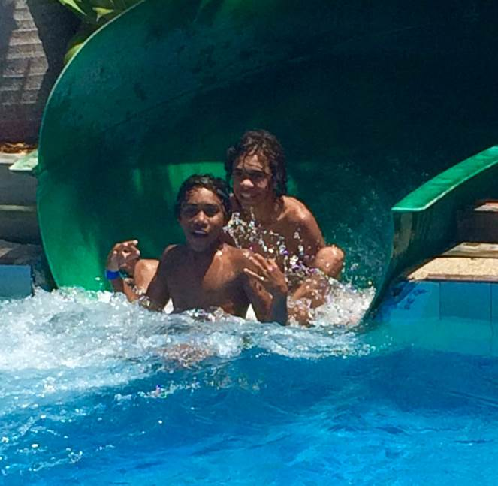
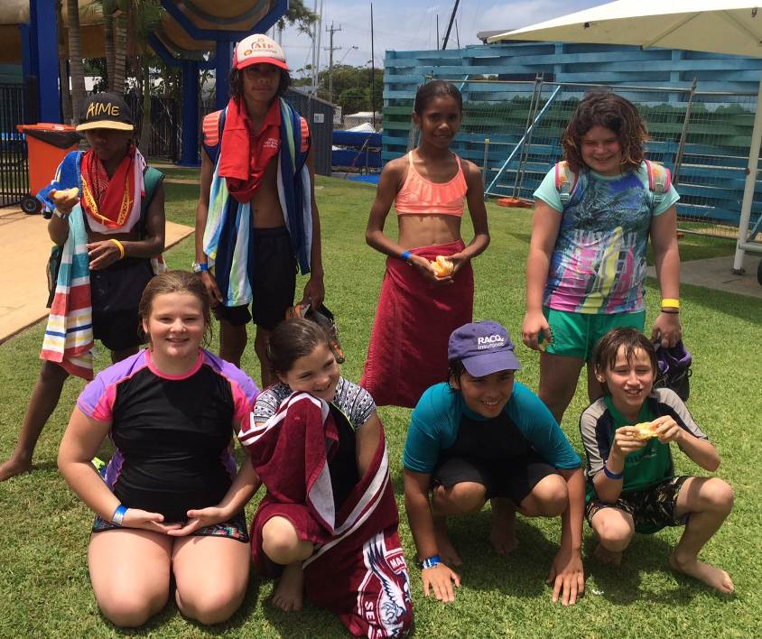

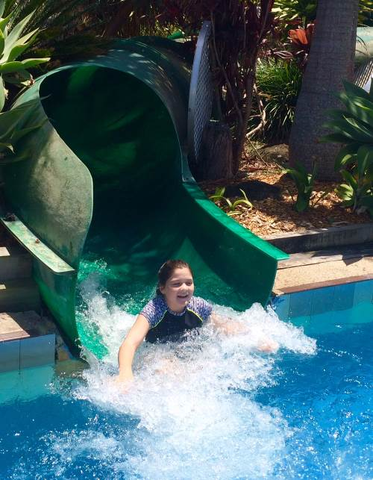
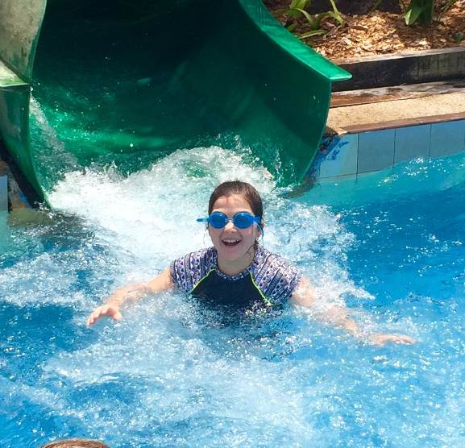

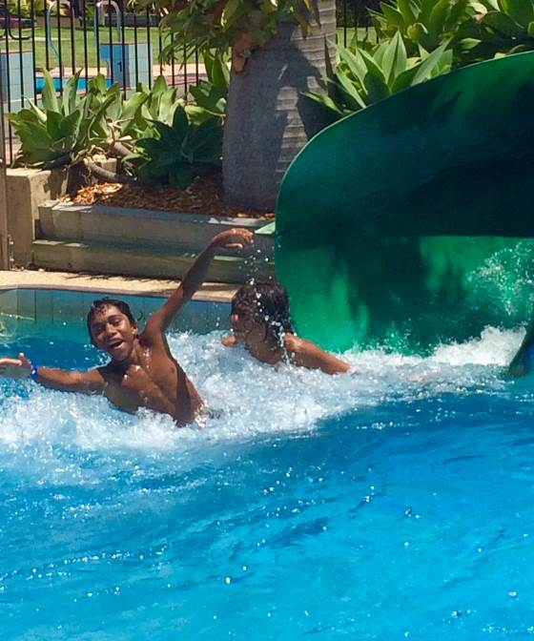
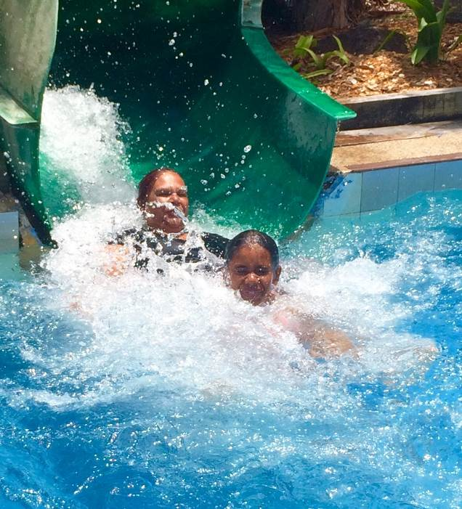

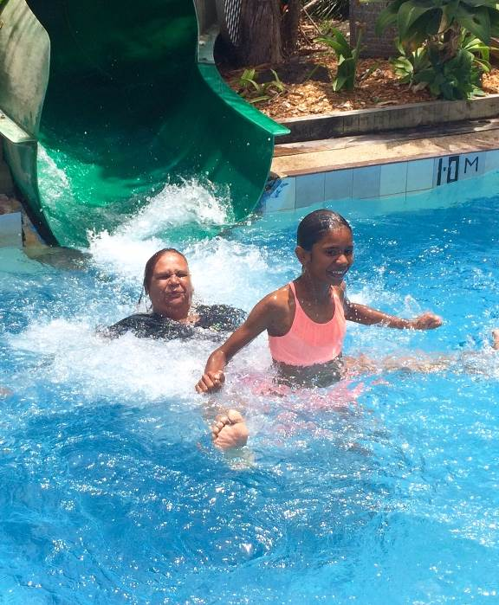

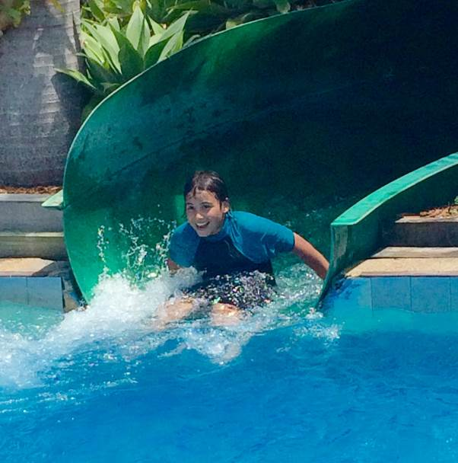

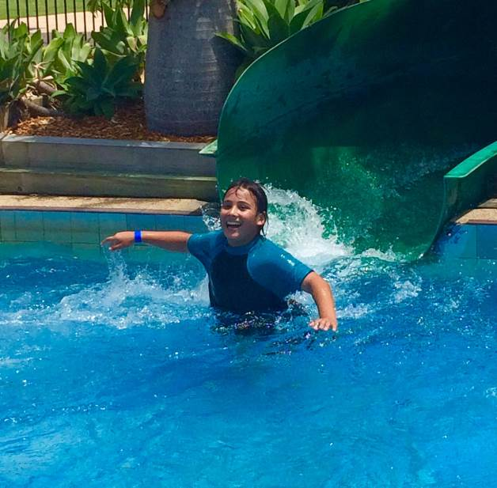

Dear Parents, Carers, Students and Community Members,
Welcome to week 8 as the end of year activities draw closer. K/1/2/3 had a wonderful time at swimming school last week and this week the Year 4/5/6 are developing their swimming skills.
The year 6 students had a great Transition to High School experience at Ballina Waterslide last week and are enjoying getting to know each other before going into year 7. Thank you to our Chaplain Allan Lambie for his organisation and to Ms Wilson (Tabulam PS) and Mrs Martin (Bonalbo CS) for accompanying the students. Year 6 student Graduation Dinner will be held at the Casino RSM on Wednesday 7th December at 6.30pm.
Last week the Prefect’s ice cup stand was a great success raising $31.70 for school programs.
Our future Captains and Prefects will be presenting their speeches at an Assembly on Tuesday 29th Nov at 3pm. All present will cast a vote for Captains and Prefects. Come and join us!
Students have all been practicing for our first Maths Challenge which takes place on Wednesday 30th Nov at 2:45pm; come and support your children and see what great maths skills they have developed.

Kindergarten 2017: Families of students starting Tabulam Public School in 2017 are invited to a Transition to Kindergarten meeting in the Library at 10:00am on Thursday 1st December. Families will be able to find out information about requirements and expectations of Kindergarten, ask any questions they have and meet Kelly Gardner: K/1 teacher for 2017.
Don’t forget to put time aside next week for our Annual Presentation Morning on Tuesday 6th December at Tabulam Hall. The Presentation will be followed by Morning Tea/Lunch back at school where we will farewell Mrs Julie Davis. Mrs Davis has been at Tabulam for many years and has assisted numerous students with their learning; she is now retiring and going to get some well-earned rest! We hope everyone can join us to say Thank You to Mrs Davis for her dedication to Tabulam Public School.
After the morning tea/lunch we will be asking everyone to join us for the opening of the Wahlubal History and Cultural Centre. This is a very exciting event and we look forward to students and community members adding to the centre developing their knowledge of the local Wahlubal people of the Bundjalung Nation. If you have any historic photos you would like us to copy to add to the Centre resources please contact Carmel McGrady, Selina

Hickling or myself. All contributions to the Centre will be treated with great respect, be greatly appreciated and will be added to the information available to our students.
We now have a design for community shirts; they are much the same as the student shirt so if you are interested in one you will need to put the sizes and number required at the office. These shirts will not arrive until next year but we will need to order them before the end of this year.
Caught being a good learner last week were: K/1- Chantelle Hippi, 2/3 – Thomas Harkin ; 4/5/6 – Kasey Khelloul. Congratulations to all!
It is great to see students always following our school rules: Be Safe, Be Responsible, Be Respectful, Be a Learner. Students on GOLD last week were:-
K/1 – Pepquita Bell-Link, Shenayah Ali, Sunni Atkinson, Sophia Hippi, Ben Wilkinson, Izaiah Ward, TL, Alfred Avery, Michael Link, Gracie Martin, Ronald Ward, Derek Hickling-Torrens, Robert Adams, Tasharni McGrady, Leanita Hickling, Shantelle Hippi, Rory Flockhart-Smith.

Year 2/3 – Shaileigh Avery, Ponjum Ward, Annabelle Johnson-Brady, Andre Avery, Charlie Avery, Shakylah McGrady, Deniarna Roberts-Walker, Keeley Bell, Shyannah Avery, Thomas

Harkin, Donald Simon, Danial Khelloul.
Year 4/5/6 – Albert Avery, Pierre Hippi, Kaden Khelloul, Anne-Maree Avery, Amber Avery, Abby Martin, Haylee White, Aaliyah Hickling-Torrens, Harrison Hone, Kasey Khelloul.
Christmas Tree Night is on Tuesday 13th December. If you wish for your child to receive a present from Santa please return the attached note along with $6 for each child. Your child must be enrolled at Tabulam School or the Tabulam Pre-school to receive a gift.
Please remember the P & C Christmas Hamper Raffle. Anyone able to donate non-perishable food items for the Hamper can leave them at the school office.
Have a great week!

Lesley Mills
Principal

WEEK | TERM 4
8 | Tuesday 29th November Captain & Prefect Speeches – 3pm  Wednesday 30th November  Maths Challenge 2.45pm  Thursday 1st December  Transition to Kinder meeting for students beginning school in 2017 at 10am in the library.  Monday to Friday, 28th November to 2 December  4/5/6 Swimming School
9 | Tuesday 6th December  Presentation Day  Cultural Centre Opening 1pm  Wednesday 7th December  Christmas Craft Day  Year 6 Dinner
10 | Tuesday 13th December  Christmas Tree Night  Book Giving Assembly  Wednesday 14th December  Attendance Rewards Day
11 | 19th & 20th December  Pupil Free - Staff Development Days

