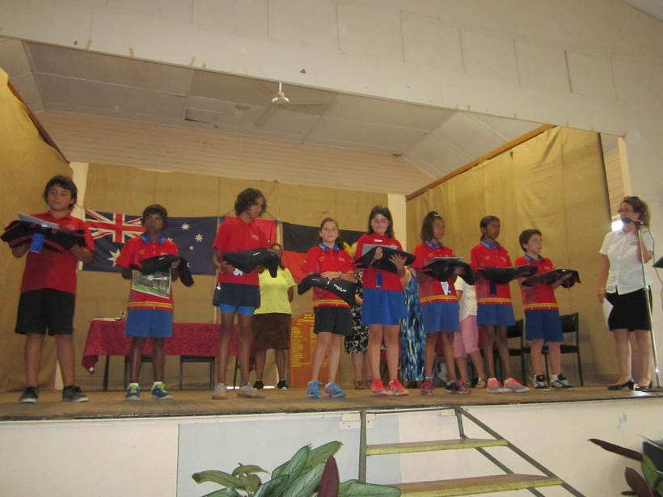

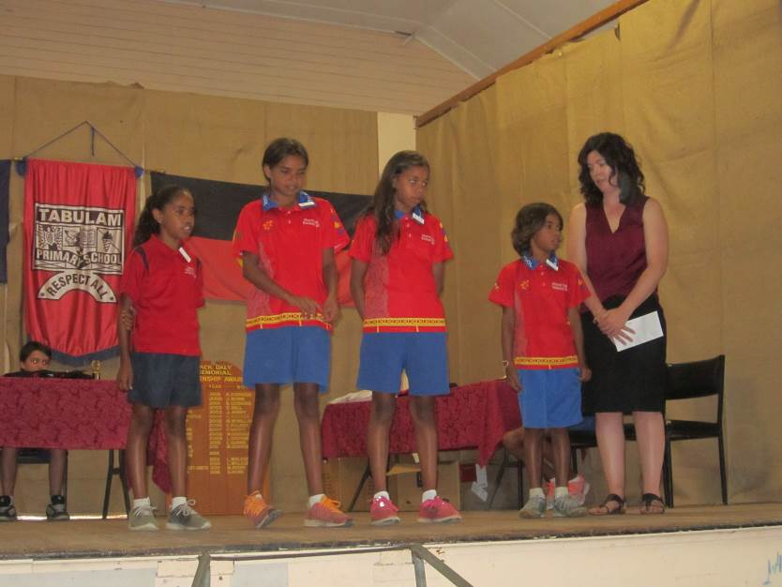

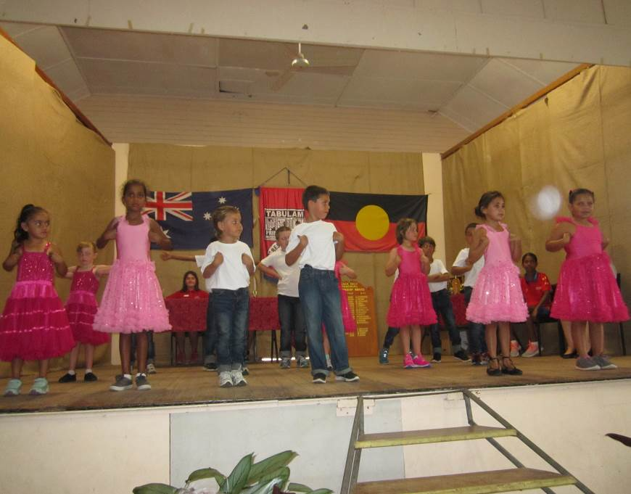
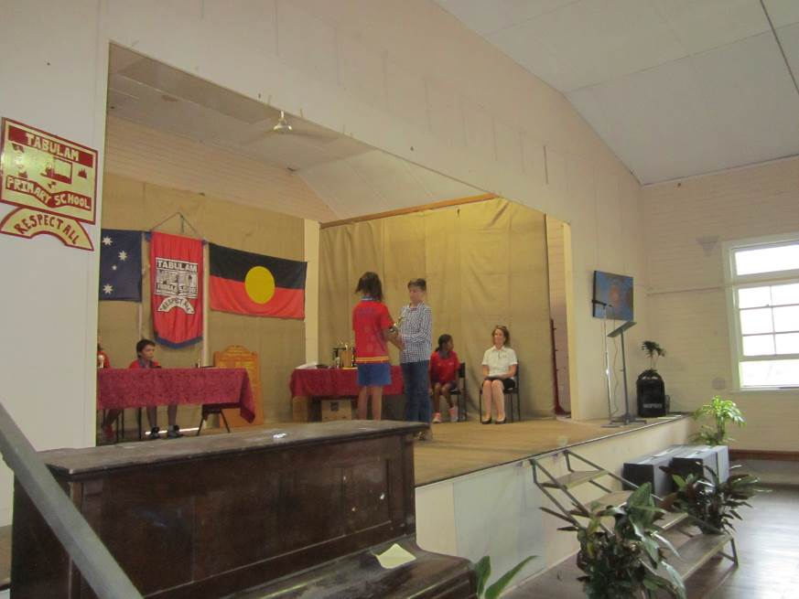

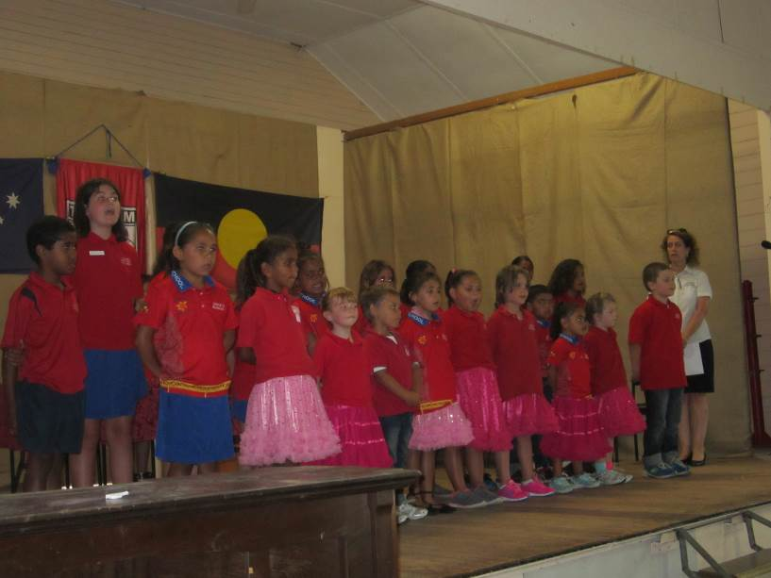

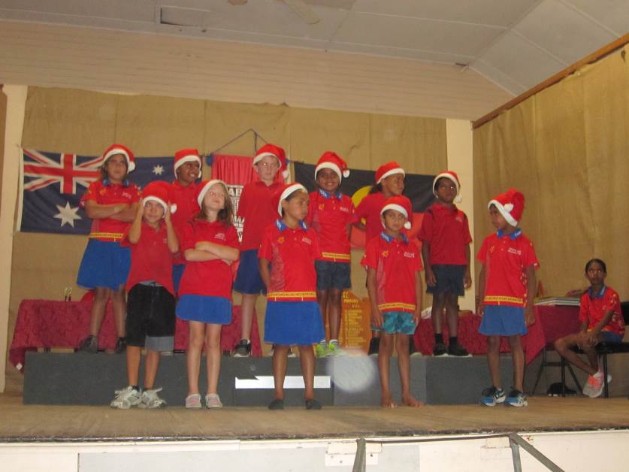

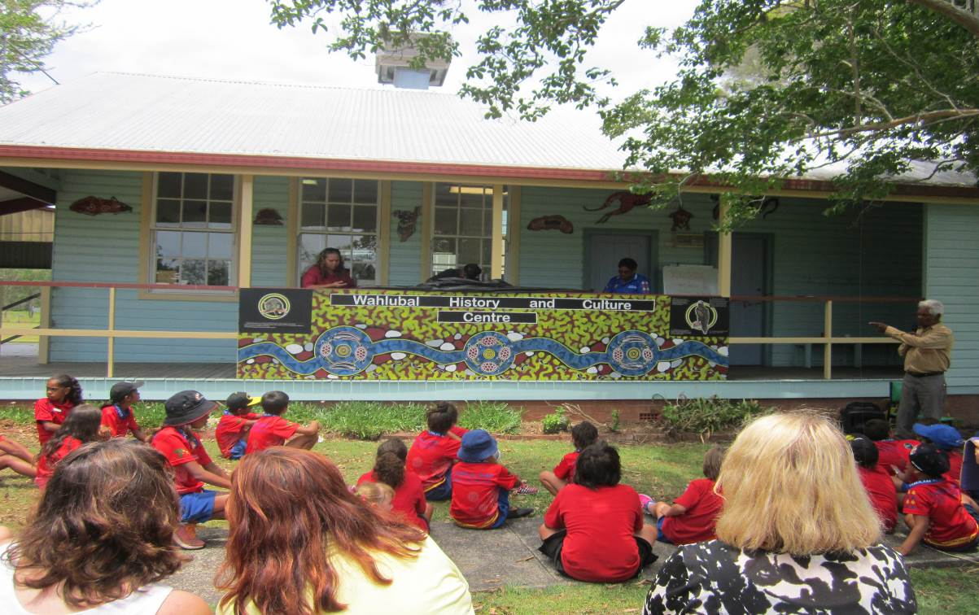

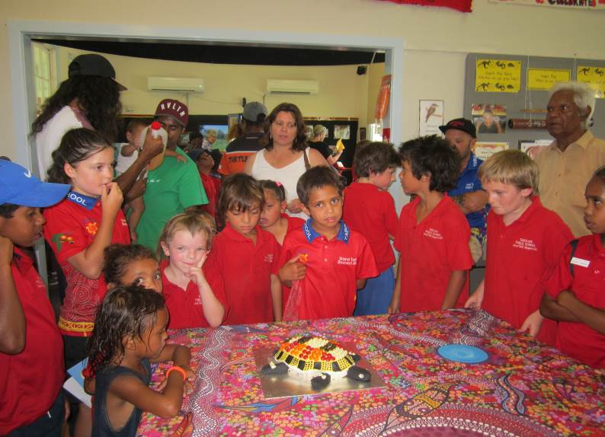

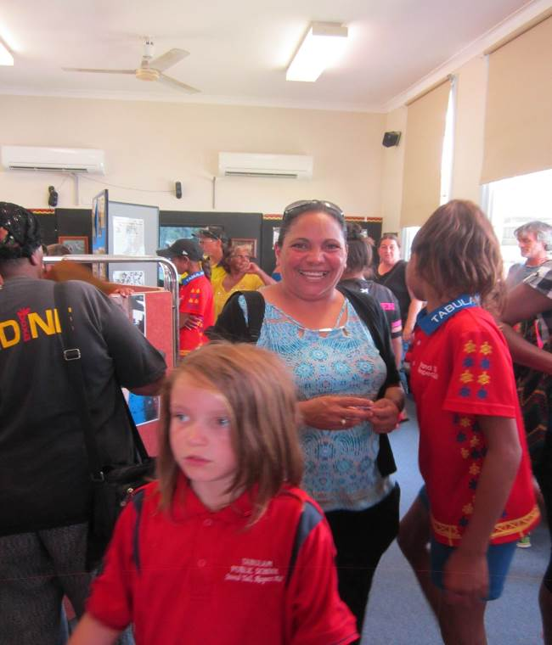
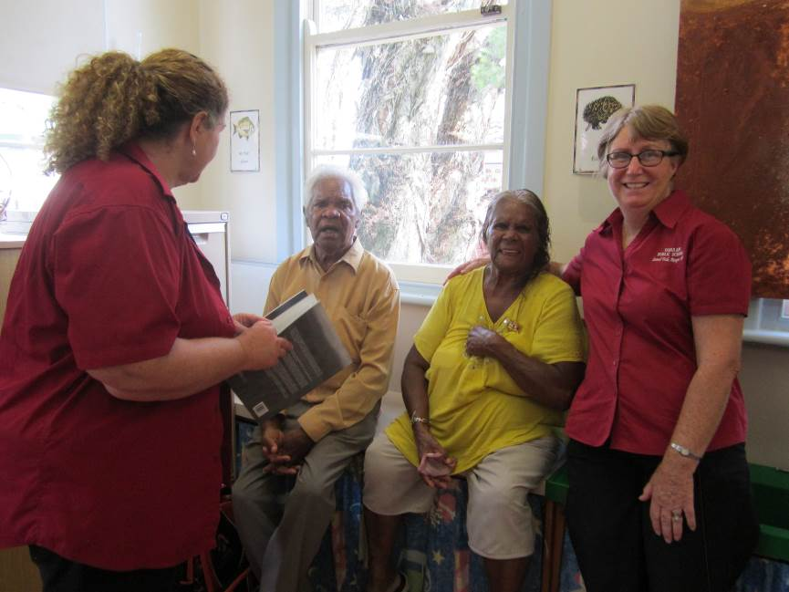

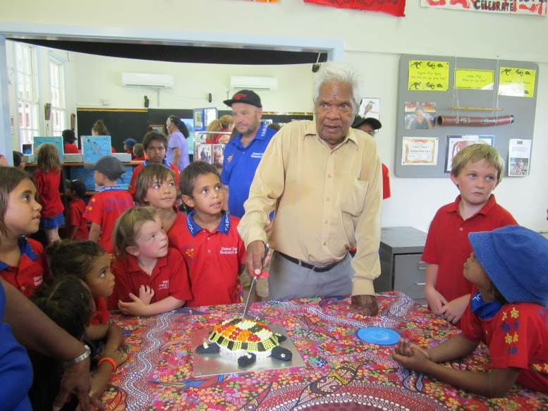

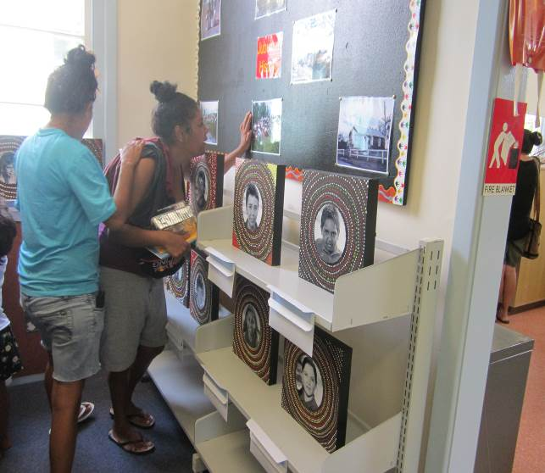

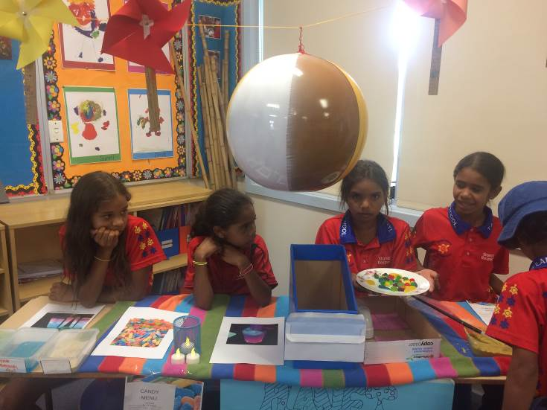
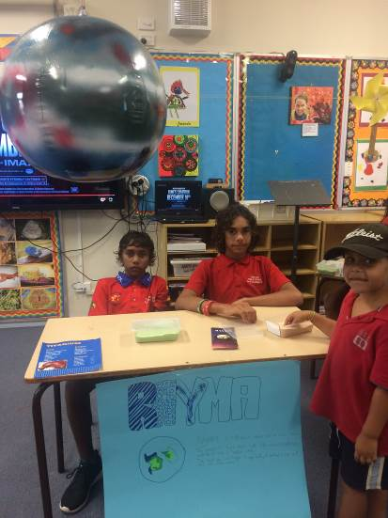

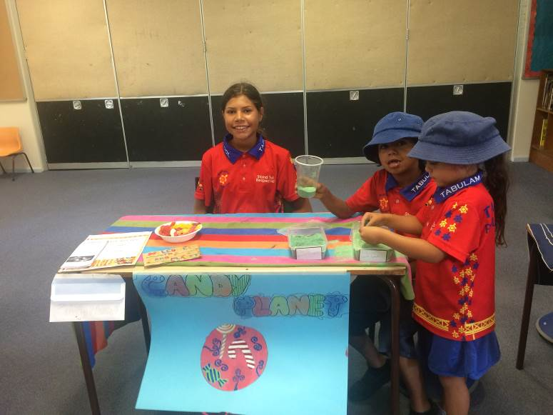
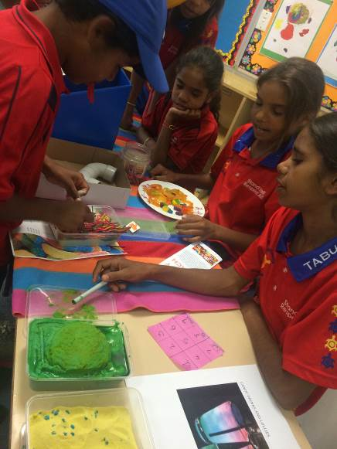

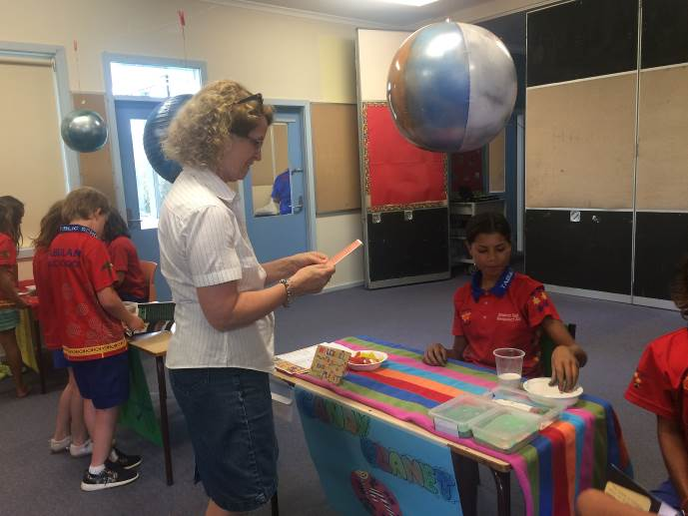
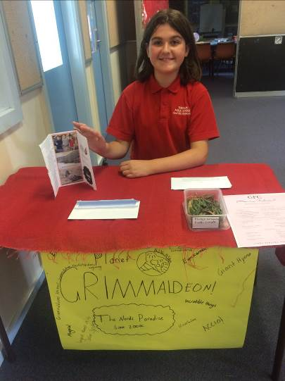

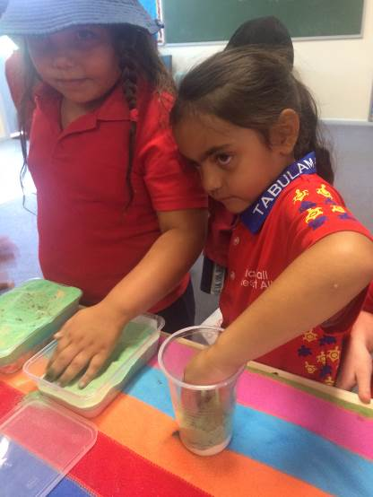

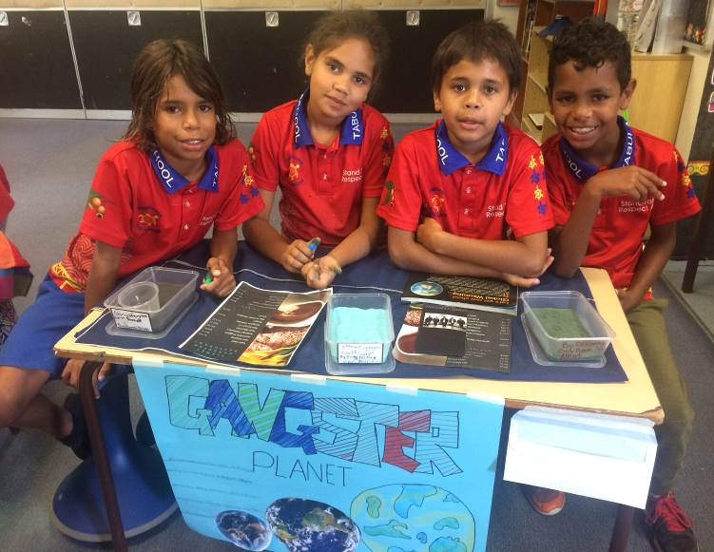

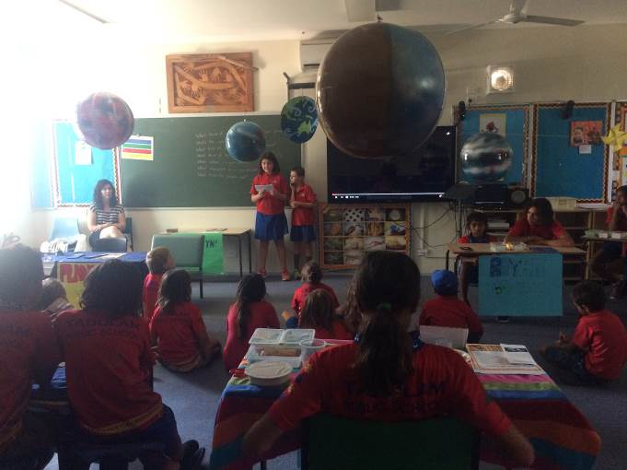

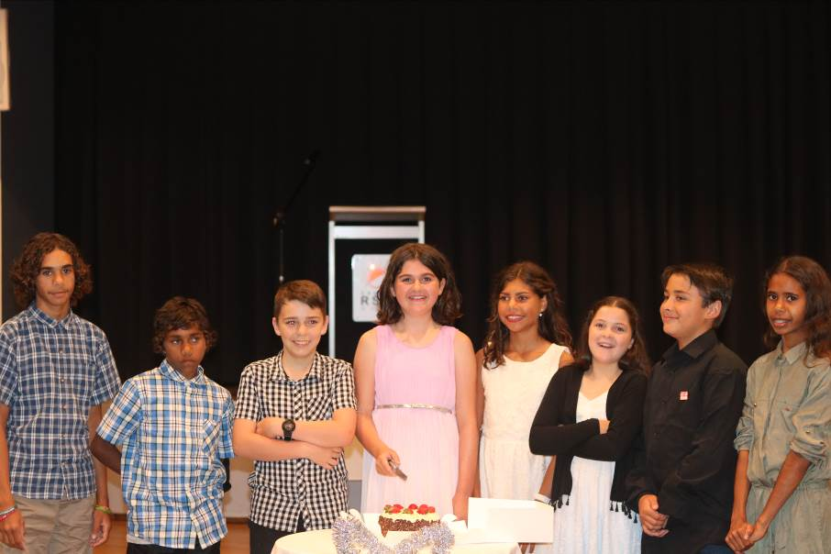

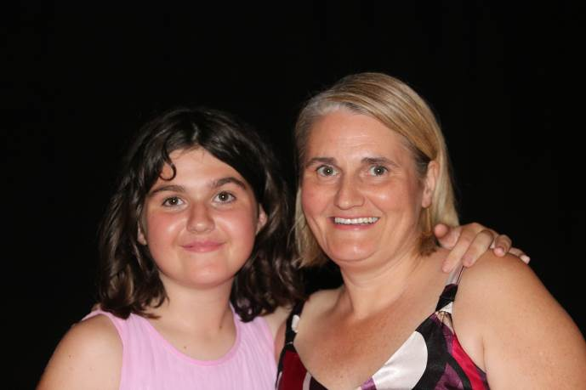

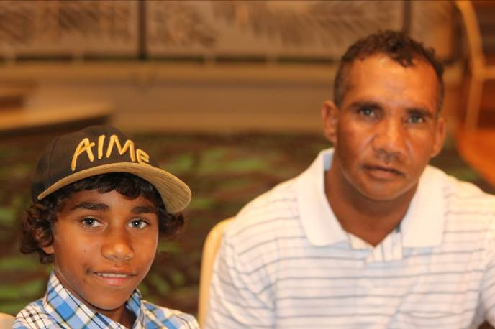

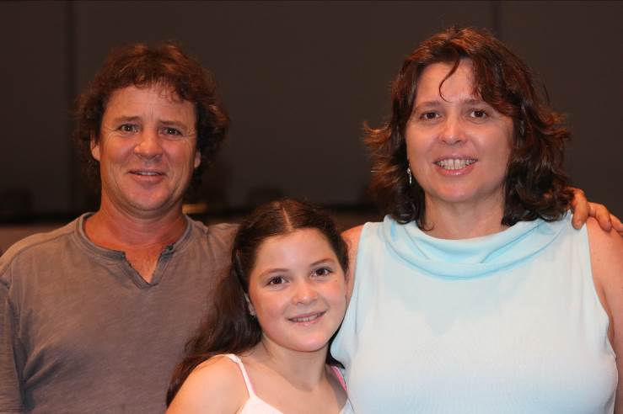

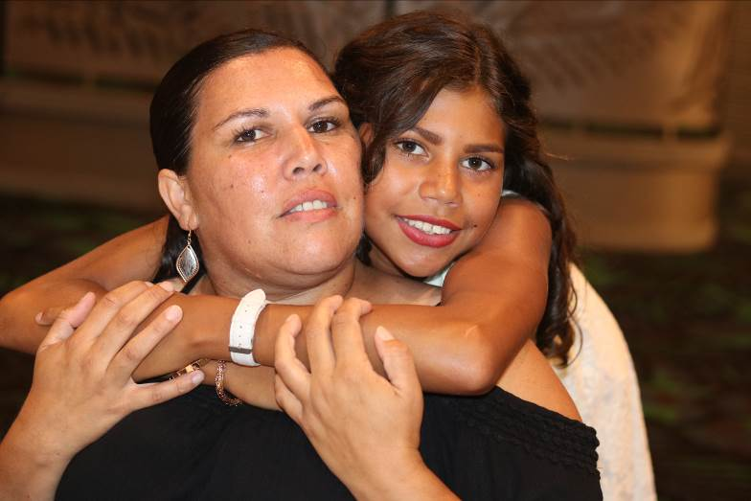

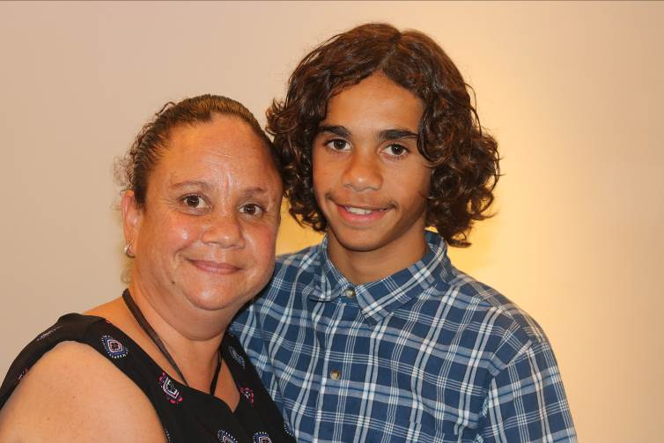

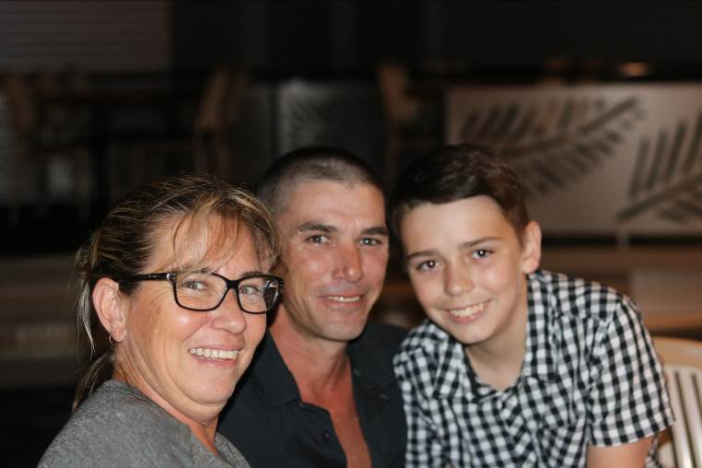

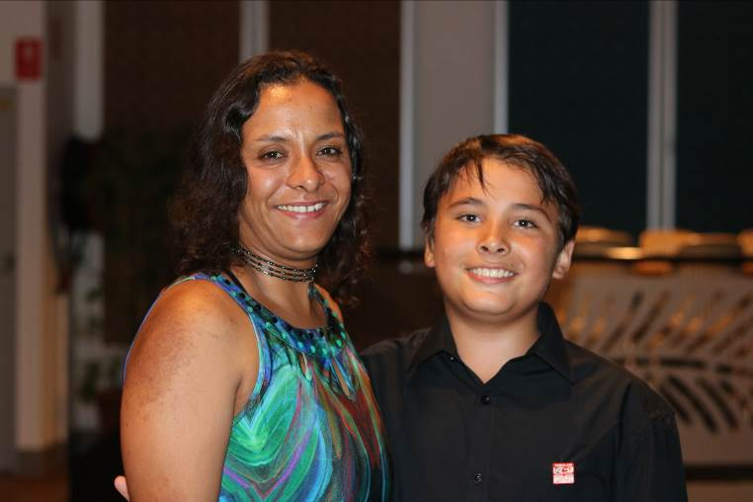

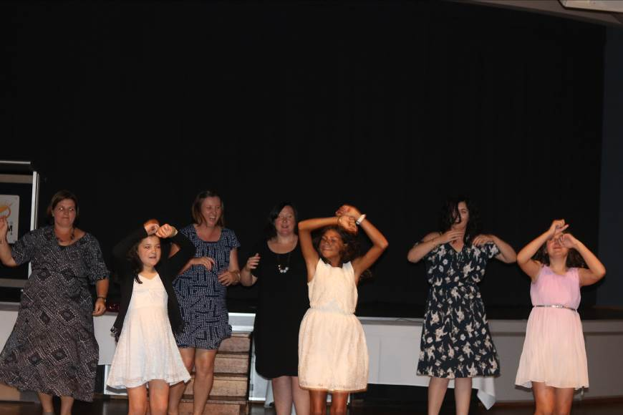

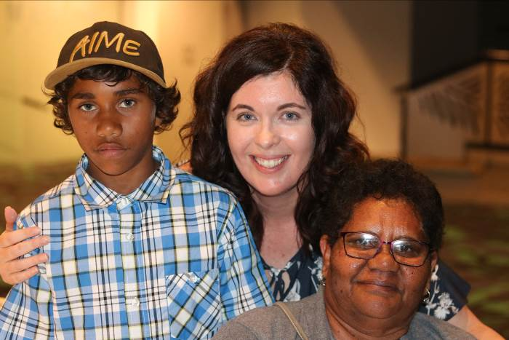

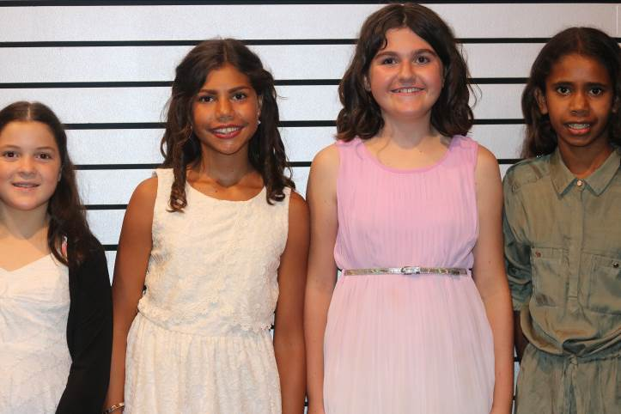

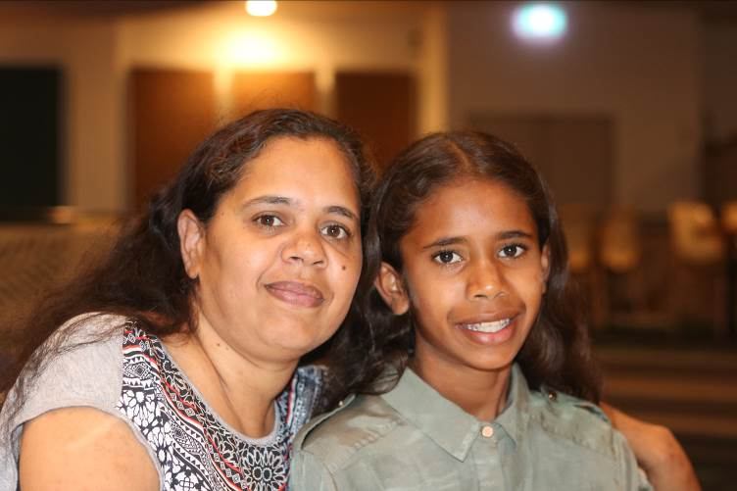

Dear Parents, Carers, Students and Community Members,
Welcome to week 10 the final week for the 2016 year.
Last week we saw many successful activities to mark the end of the year. Our Annual Presentation Mrs Davis’ retirement and the opening of the Wahlubal History and Culture Centre made for a wonderful day on Tuesday. Thank you to everyone who attended.
Our Christmas Craft Day and the Year 6 Graduation Dinner followed on Wednesday and both went well. It was lovely to help the Year 6 students and their families celebrate their graduation from Primary school and we wish them well for their High school years and look forward to hearing about all of their successes into the future.
Tuesday 13th December is a busy day with a community BBQ, our Book Giving Assembly and Christmas Tree. The free community BBQ will be at the Tucker Box in Jubullum Village at 11:00am. Allan Lambie and the Principal of Bonalbo and myself will be there to enjoy a burger and a catchup with everyone so come along, everyone is welcome.

The Book Giving Assembly will be at school at 2:30pm and we have local author Rowan McDonagh attending to

share her stories as an author with us.
Christmas Tree is also on tomorrow (Tues 13th) the P & C BBQ will be at 6pm, carols will be at 6:30pm and Santa will arrive at 7pm followed by our lantern parade and dancing for all! There will be glow products available for sale on the night. Come along and have a fun family night together.
Eligible students will attend our last Attendance Reward Day for the year on Wednesday 14th December. Students will be leaving at 9:30am to go to Casino Pool. Students must have had no more than 5 days away from school this term.
On Thursday the Legal Service will be here to assist community members with any queries they may have, please see attached flyer. Application for Birth Certificates will be available.
Friday 16th December is the last day for students for 2016. Staff will attend for a Staff Development Day on Monday 19th December.
Students ‘Caught Being Good Learners’ last week were: K/1; Gracie Martin, 2/3; Danial Kelloul, 4/5/6; Montique Avery.
It is great to see students always following our school rules: Be Safe, Be Responsible, Be Respectful, Be a

Learner. Students on GOLD last week were:-
K/1 – Pepquita Bell-Link, Shenayah Ali, Sunni Atkinson, Sophia Hippi, Ben Wilkinson, Izaiah Ward, Alfred Avery, Michael Link, Gracie Martin, Derek Hickling-Torrens, Robert Adams, Leanita Hickling, Rory Flockhart-Smith.

Year 2/3 – Shaileigh Avery, Ponjum Ward, Annabelle Johnson-Brady, Charlie Avery, Keeley Bell, Shyannah Avery, Donald Simon.
Year 4/5/6 – Albert Avery, Pierre Hippi, Oscar Martin, Kaden Khelloul, Dellmay Simon, August Avery-Robinson, Anne-Maree Avery, Amber Avery, Abby Martin, Haylee White, Aaliyah Hickling-Torrens, Montique Avery, Harrison Hone, Kasey Khelloul.
Your children (particularly the K-4 children) will benefit greatly if you can find the time over the break to enjoy some books together, write some stories or shopping lists, discuss programs on tv, play some counting games etc; as the 5 week holiday is a long time without practise in these areas.
Thank you to all who have supported Tabulam Public School throughout the year, we have a wonderful school and it is because of the dedication of our whole school community: staff, parents, students and the wider community. We look forward to continuing the journey in 2017.

We wish you all a Merry Christmas and a great start to the New Year.

………………
Lesley Mills
Principal

WEEK | TERM 4
10 | Tuesday 13th December  Christmas Tree Night  Book Giving Assembly  Wednesday 14th December  Attendance Rewards Day
11 | 19th & 20th December  Pupil Free - Staff Development Days

Christmas Tree/Dance & Carols
Night ($6 per child)

I would like my child/children
…………………………………………
who is/are enrolled at Tabulam School to receive a gift from Santa.

Signed:………………………………....
Parent/Carer $.............

I would also like my child ………….
………………….. who is enrolled at Tabulam Pre-School to receive a gift from Santa.

Signed:…………………………………..
Parent/Carer $.............

