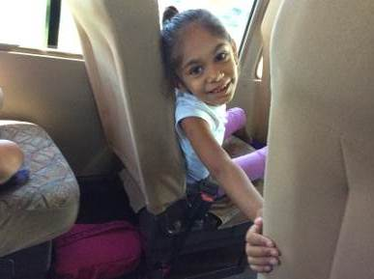
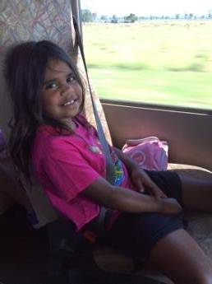
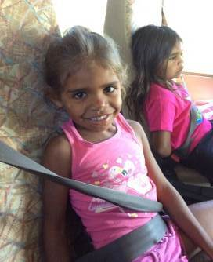

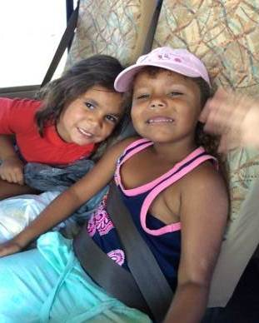
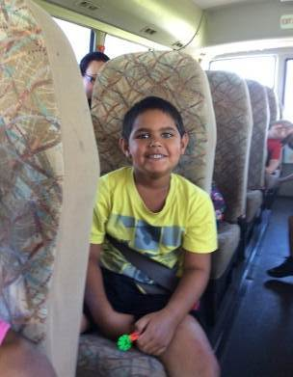
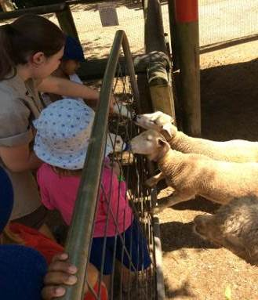

k/1 excursion to macadamia castle

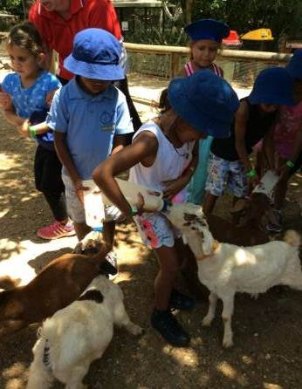
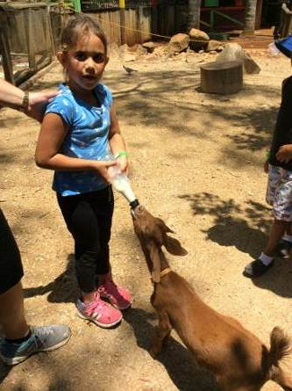
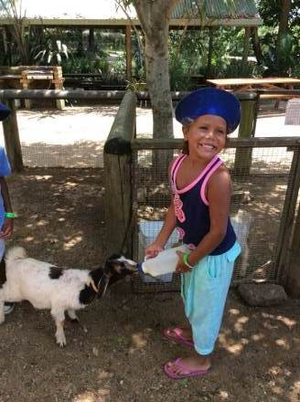

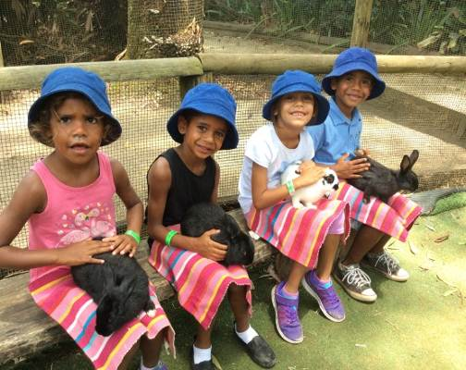
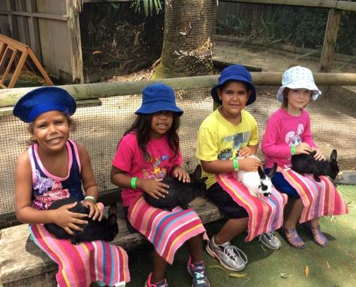

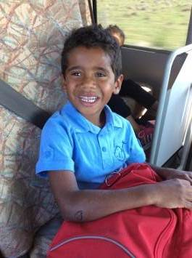
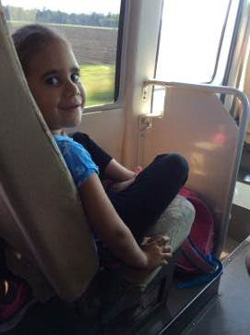

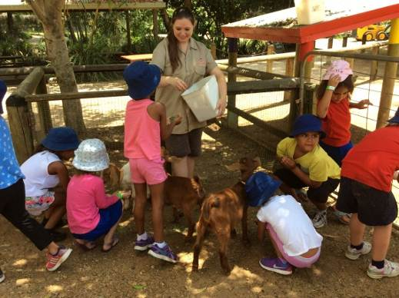

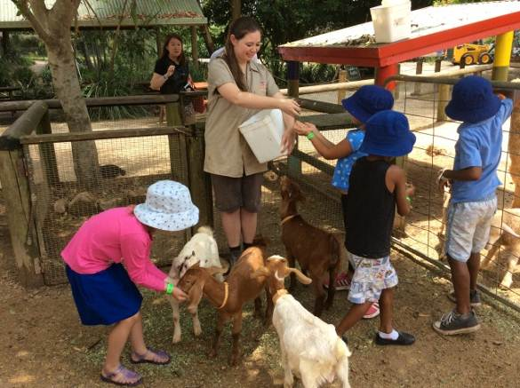

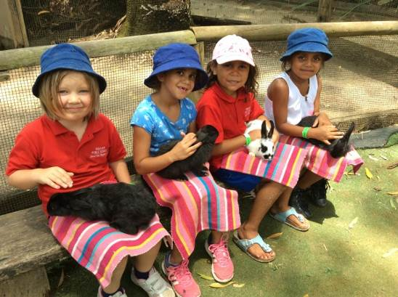

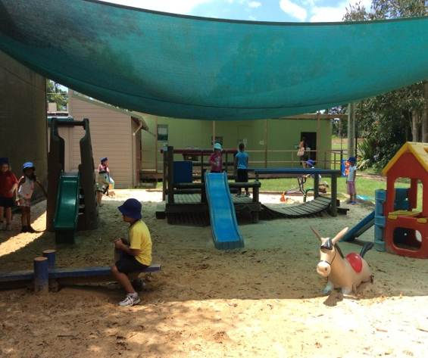
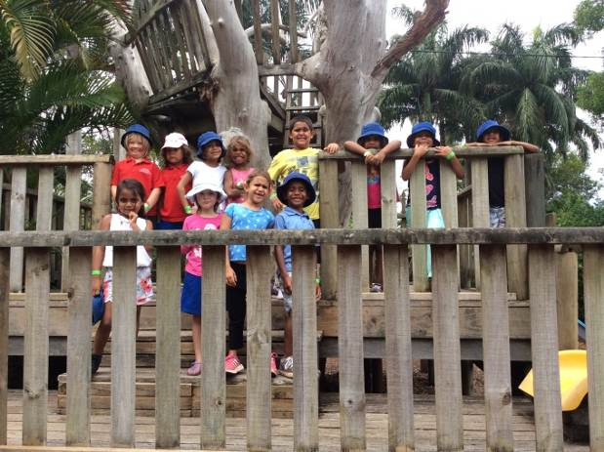

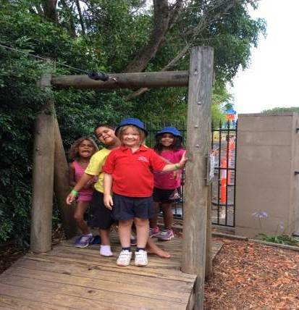
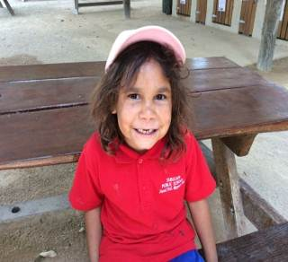

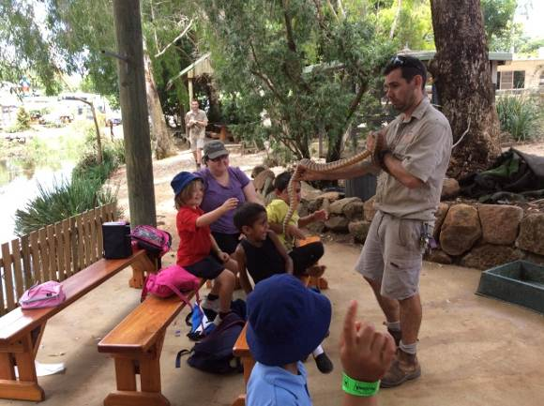
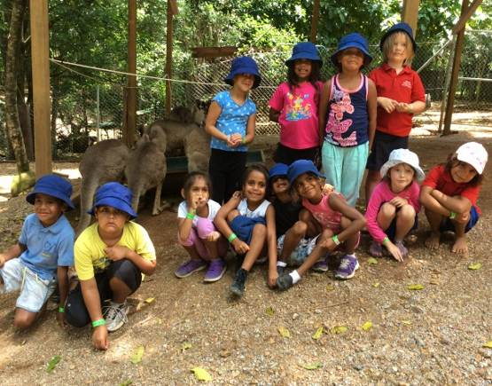

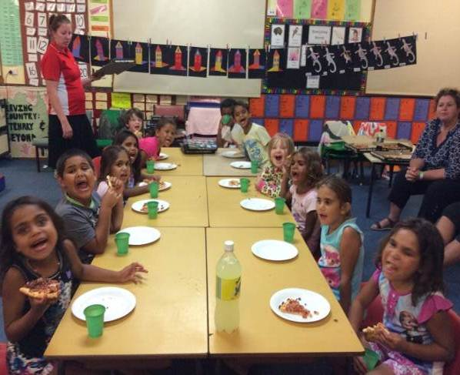
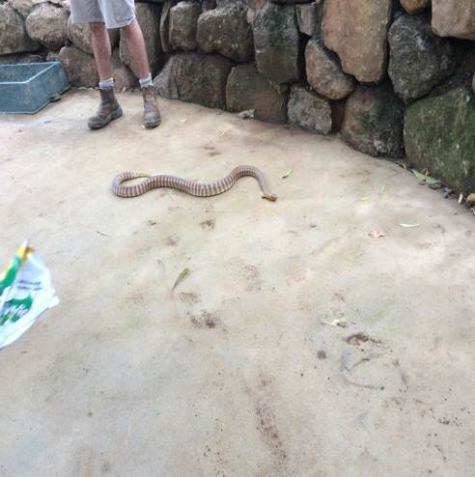

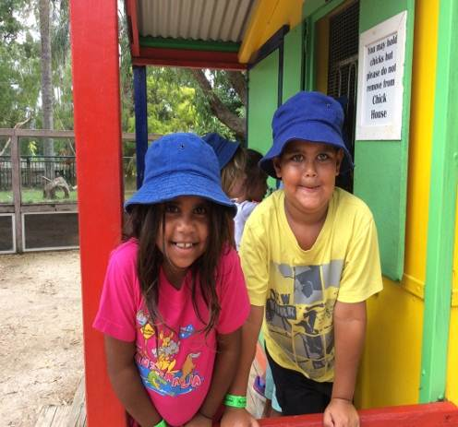

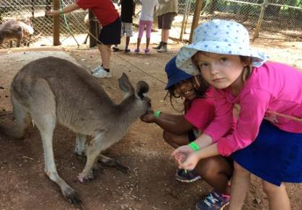
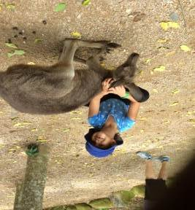

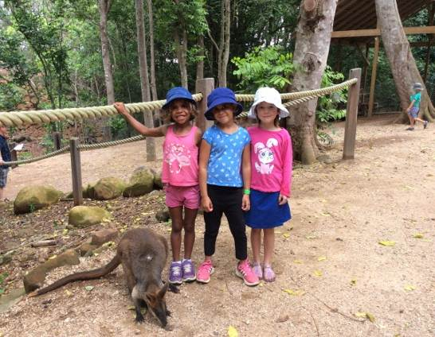

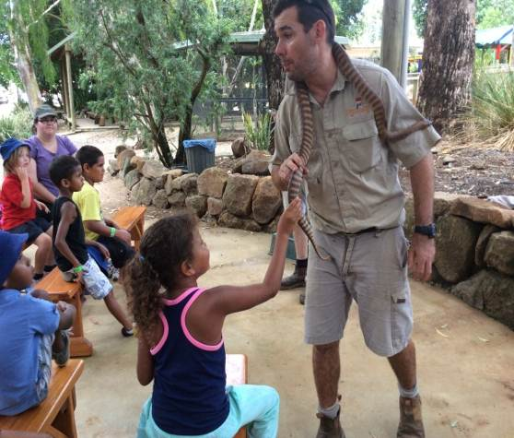

Dear Parents, Carers, Students & Community Members,
Welcome to week 9, a very busy week. Our Year 6 students will attend their Year 6 Graduation Dinner in Casino at 6.30pm on Tuesday, we hope they have a lovely evening as they celebrate the completion of their Primary schooling at Tabulam Public School.
Well done to K/1 for presenting our assembly last Tuesday, it was good to see a number of parents in attendance. Thank you for your support.
K/1 had a lovely time on their camp last week, they were full of stories about the animals at Macadamia Castle and their sleep over, where they all slept very well! Thanks to staff for giving their time to ensure the students had a great experience.
Kindergarten 2015 Orientation will take place on Wednesday at 10am in the school library. This is an information session for parents of all students who are starting school next year (2015). Class routine, school procedures and expectations will be discussed, please take the time to come along and join the group, tea, coffee and nibbles will be available.
On Thursday morning at 9.30am all year 5 students will present their election speeches for 2015 Captain /prefect. Students may need help with their speeches, please take an active part in supporting your child with their speech. Captains and prefects for 2015 will be announced at our Presentation morning on Tuesday December 9th.
After lunch on Thursday students will take part in Christmas Craft activities which will be the basis of writing activities for the following days. Photos of the activities and student writing will be compiled to make class books for students to read.
Teachers are busy completing end of year reports for students. The reports will be available after Presentation on Tuesday December 9th. There will be time to chat to teachers about your child’s reports if you wish to.
The P & C will be again handing out Christmas gifts at the Christmas Tree/ Dance on Tuesday16th December. If you wish your child to receive a present from Santa the cost will be $6 each for students enrolled at Tabulam School and Tabulam Pre-School. Please fill in the permission note at the end of the newsletter and return to school along with the correct money.
The following students are all on gold:
Kindy – Andre Avery, Deniarna Roberts-Walker, Annabelle Johnson-Brady, Scott Hickling, Shakylah McGrady, Shaileigh Avery, Breanna Ward, Ponjum Ward, Sarah Maag.
Year 1 – Charlie Avery, Keeley Bell, Donald Simon.
Year 2 – Anne-Maree Avery, Albert Avery, Oscar Martin, Dellmay Simon, Anastasia Zervos, August Avery-Robinson.

Year 3 – Amber Avery, Kendita Avery-Robinson.

Year 4 – Abby Martin, Haylee White, Aaliyah Hickling-Torrens, Montique Avery, Harrison Hone, Bradley Avery, Jacinta Hill, Nickali Waldon-Whittaker, Hannah Maag.

Year 5 - Michael Zervos, Matthew Avery, Azrianna Holt, Keanu Buchanan, Mikaela Hickling-Mundine, Byron McAnulty, Louise Flockhart-Smith.

Year 6 - Maria Hickling, Crystal Ross, Lachlan Walker, Madison Avery, Noah Maag.
Students receiving the ‘Caught being Good’ book prizes for great application last week are:
K/1; Breanna Ward, 2/3; Anastasia Zervos; 4/5/6; Malcolm MacIntosh.
Great work!

Have a great week.
Lesley Mills

Principal

Term 4 | What’s Happening
Week 9 | Tuesday 2nd December  Year 6 Dinner – 6.30pm  Wednesday Dec 3rd – 10.30am  Kindy Orientation Meeting  10.30am
Week 10 | Tuesday 9th December  Annual Presentation  Wednesday 10th December  Book Giving Assembly
Week 11 | Monday 15th December  Rewards Day at Casino Pool  Tuesday 16th December  Christmas Tree/Dance & Carols Night

Christmas Tree/Dance & Carols Night
I would like my child ……………………. who is enrolled at Tabulam School to receive a gift from Santa. I understand the cost is $6 per child.
Signed: ……………………………………..
Parent/Carer

Amount enclosed: $ …………

I would also like my child ………………
…………….. who is enrolled at Tabulam Pre-School to receive a gift from Santa. I understand the cost is $6 per child.

Signed: ……………………………..
Parent/Carer

Amount enclosed: $ ………….

