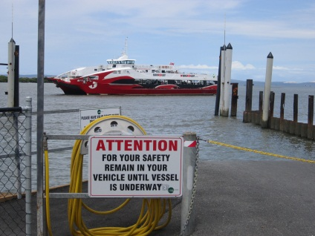
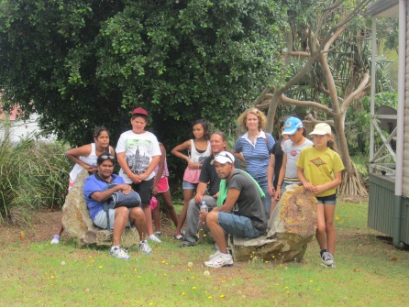

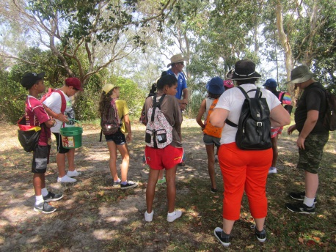
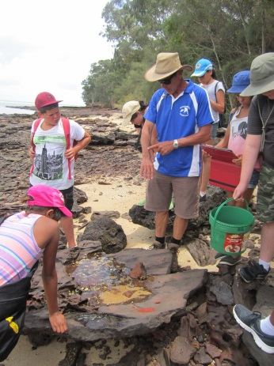

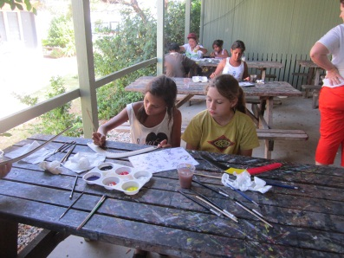
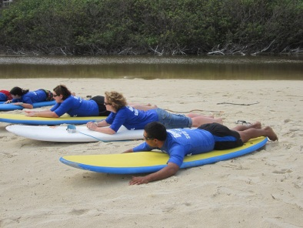

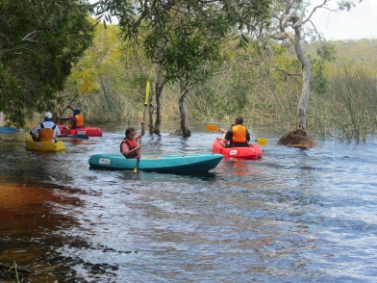
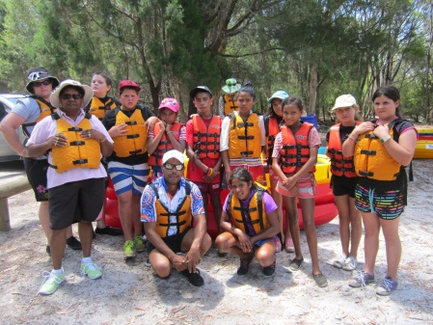

Year 5/6 Excursion
Stradbroke Island

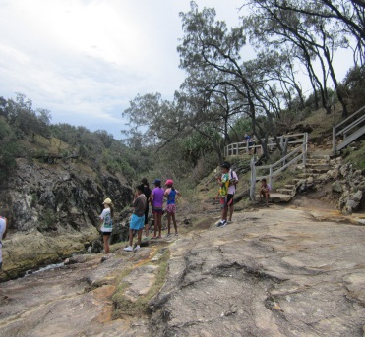
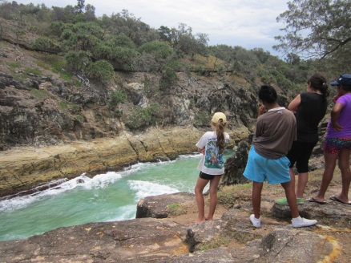

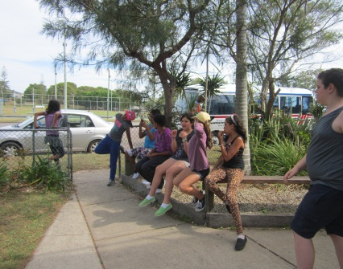

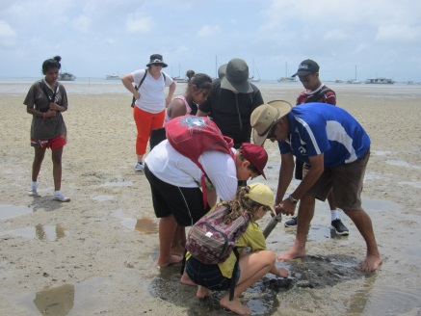
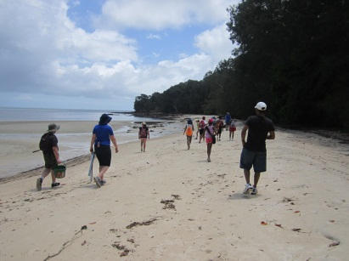

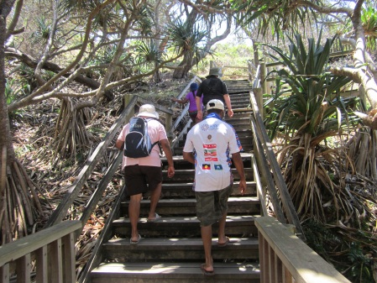
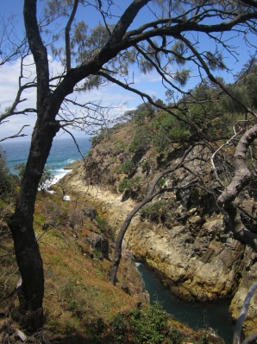

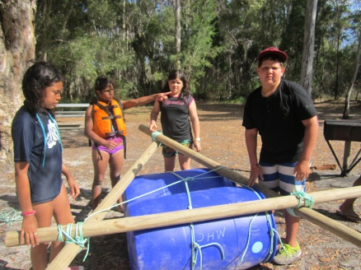
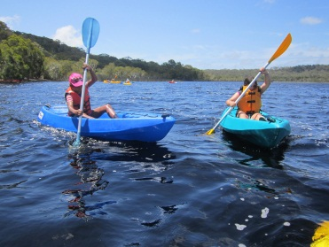

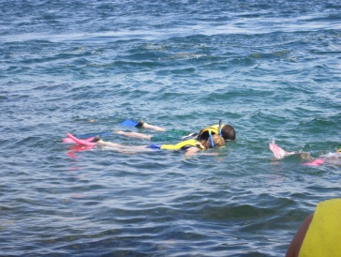

Dear Parents, Carers, Students and Community members,
Welcome to week 7 and a return to school for Yr. 5/6 campers who had an excellent time at Stradbroke Island.
Our K/1/2 students have their intensive swimming program this week. Please make sure all students have their clothes clearly labelled and a plastic bag for wet swimmers and towel. Years 3/4/5/6 will attend next week.
Students will be having final year assessments over the next couple of weeks in order for teachers to complete end of year reports. It is great to see how many students always put in their best effort to their learning. Well done!
There are a number of end of year events coming up so make sure you mark them on your calendar. The engagement and involvement of parents and carers in their child’s education is essential for children to feel supported at school. Check the calendar in this newsletter.
On Friday there will be a visit from Lismore Police Community Liaison Officers to talk to students about staying safe in a variety of situations and what Police do as part of their job.

Students on Gold Level:
Kindergarten: Shyannah, Keeley, Miah, Charlotte, Charlie, Malachi, Donald.
Year.1/2: AnneMaree, Dellmay, Anastasia, Albert, August, Pierre,Oscar, Samuel, Michael, Amber, Kendita, Cheyanne, Christine, Antwone, Bing.
Year 3/4: Aaliyah, Mikaela, Jacinta, Abby, Haylee, Matty, Azrianna, Montique, Tamia, Tamika, MichaelZ, Harrison, Hillary, Louise, Shaquille.
Year 5/6: Cleo, Leroy, Ally, Madison, Crystal, Maria, Lachlan, Hayley, Lakeisha.
Have a great week!

Lesley Mills
Principal
Tabulam P & C
Thank you to everyone who helped organise and make sandwiches for Tabulam Race Day. Your contribution was really appreciated.

Pastor Pete is a member of the school pastoral care team and available to-
-provide support for students

-refer students/ parents to specialist services -assist staff -provide crisis support Pastor Pete is also a member of
the Parents and Citizens Association. If you have any ideas or concerns you would like the P & C to address you are welcome to discuss these with Pastor Pete.
Pastor Pete is available at school on Mondays and Fridays, in person or by phone (66661219). He can also be contacted at home on 66625170 or pjboughey@optusnet.com.au

December issue is the last edition of THE BRIDGE for 2013.
Closing date for new ads and all contributions is Friday November 22nd. Please send in your articles and photos for your local community voice before Nov. 22nd so the December edition of THE BRIDGE can be a bumper issue!!!
After December THE BRIDGE will not be published until school resumes in 2014.
Thanks to everyone who has supported THE BRIDGE in 2013. It really has been great to see it change and grow into something now anticipated... and with so much encouragement I have felt privileged to be involved. Happy Festive Season and thanks again. Bhadrena Rose

On Friday 22nd November, Pastor Peter Boughey will be having a film night commencing at 7pm. The movie that will be shown is called ‘Blue Sky epic’ from the creators of Ice Age. The cost will be a gold coin donation and the Canteen will be open at 6.30pm for snacks only. Proceeds of the night will go towards graduation.

Week | What’s Happening
7 | Monday 18th Nov-Fri 22nd.Nov  Swimming School K/ 1/ 2.  Friday 22nd November  Film Night 7pm
8 | Monday 25th Nov-Fri 29th Nov  Swimming School Yrs. 3/4/5/6  Tuesday 26th November  Dr. Jackie Andrews
9
10 | Tuesday 10th December  Annual Presentation/ PLP Day/ Lantern Making/BBQ lunch  Wednesday 11th December  Year 6 Dinner
11 | Tuesday 17th December  Xmas Tree/Dance/Carols

Bonalbo Central School P & C are having a Carols & Market night at Bonalbo Primary School on Saturday 30th November, commencing at 4pm. Come along and have a fun night – we will have food stalls, market stalls, monster raffles, Santa will be there, ‘The Messengers’ will be there to entertain with music and Christmas Carols. Stall holders are welcome, please book. $15 per site. Enquires to Michelle – 66655124; Raelene – 66655175; Hellan – 66653152.

Tabulam Public School
Christmas Tree/Dance Permission Note.
I wish my child/children
………………………………………………
to receive a present from Santa.
Preschooler Name:
………………………………………………
Signed: …………………(Parent/Carer)
Cost: $6 for school students and pre-schoolers.

