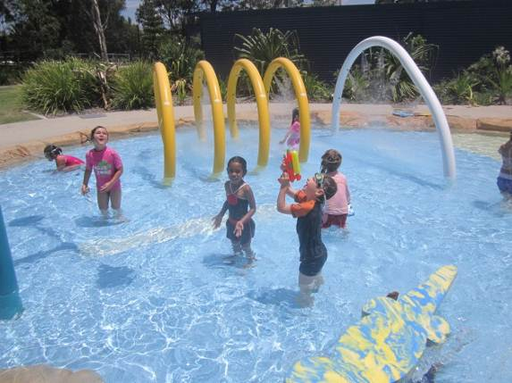
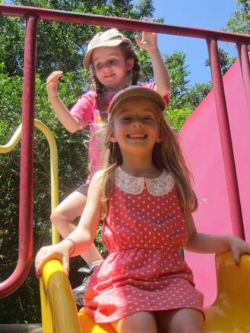
K

Kindergarten Excursion
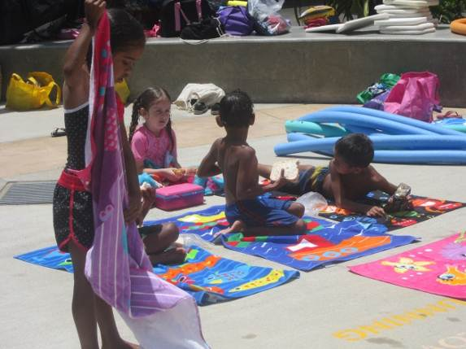


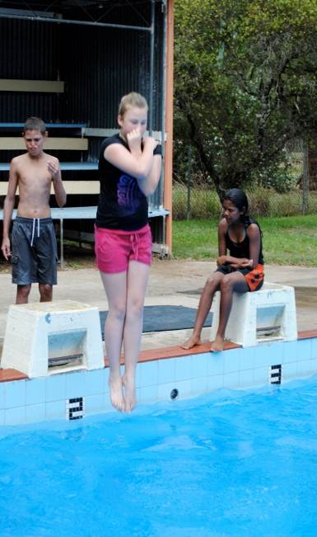
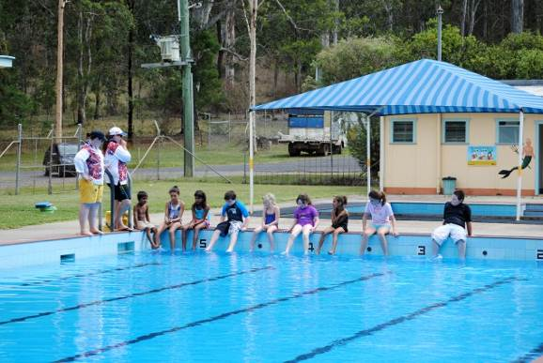

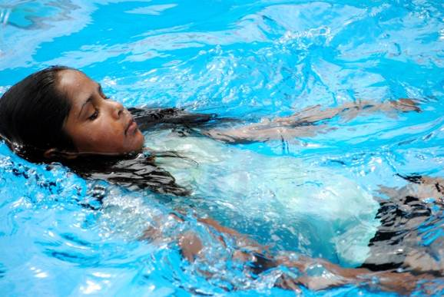
SWIMMING SCHOOL

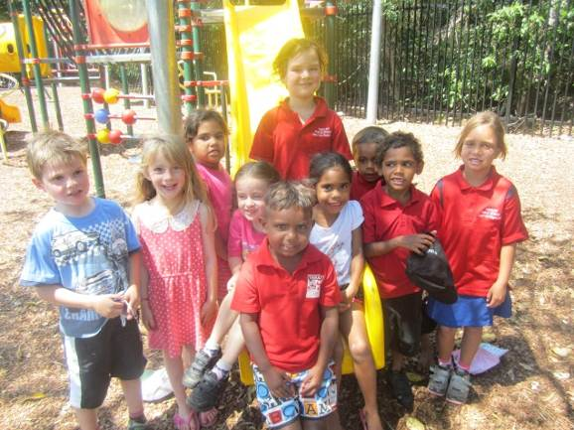

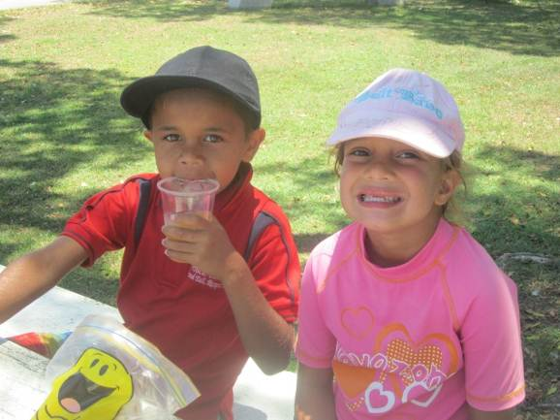

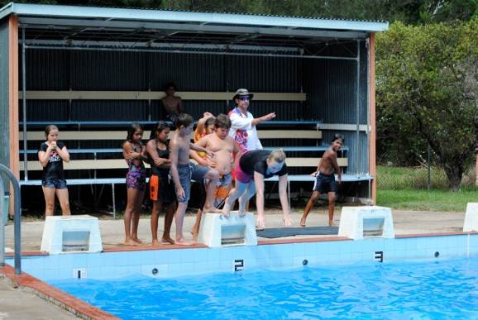

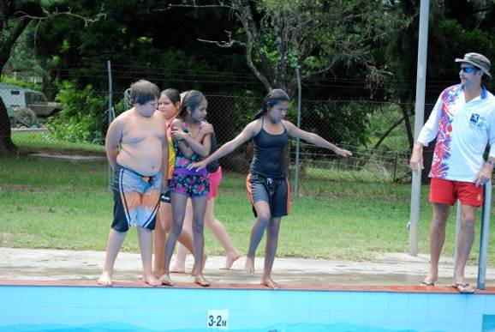

Dear Parents, Carers, Students and Community Members,
Welcome to week 9 and the excitement of our Annual Presentation morning. We hope everyone can attend tomorrow at 10am in the Tabulam Hall to celebrate the achievements of Tabulam Public School students over the 2012 year. Our Year 6 Graduation Certificates will be presented by Mr. Trevor Hodges who will be relieving Principal at Bonalbo Central School for 2013.
Year 5/6 will present their final assembly for 2012 – for Yr. 6 students it will be their final primary school assembly. Come along on Wednesday at 2.45pm and give them your support.
Our Year 6 students will attend their Year 6 graduation dinner at the Casino RSM on Thursday night. Everyone is very excited and looking forward to a fun evening.
Next week our Tabulam Xpress reporters will head to Lismore for the Newspapers in Education Awards at Lismore City Hall. They did a great job with their newspaper and we wish them all the best at the award ceremony.

Kindergarten orientation day will be held on Monday 10th December at 9.30am.
Our Attendance Reward activity will take place at school on Tuesday 11th December. Students who have had 5 days or less away this term will be eligible to take part. Cost for this day will be $10 per child and the students will receive a show bag of their choice and take part in fun water activities.
Carols and Christmas Tree Night will be held at the school on Tuesday 11th December starting at 6pm with a BBQ, followed by the choir singing, Santa arriving and then dancing for all. Come along and bring the family and help us celebrate the Christmas spirit.
All school Library books are to be returned to school as soon as possible. A $10 payment must be made to the school to cover costs of replacing them if books are lost or damaged.
Have a great week!

Lesley Mills,
Principal

YE OLDE P & C CHRISTMAS NEWS
- Just a reminder to return notes with $6 for each child for Christmas Tree and Dance night and Carols by Candlelight on Tuesday 11th December. Due to the fundraising efforts of the P & C we are able to subsidise the cost of these presents.
- The P & C has nominated Kylie Martin for the Healthy Kids Canteen Recognition awards for her dedication to the canteen and the Healthy Kids Fresh Tastes Canteen Management Strategy.
- Thank you very much to everyone who kindly volunteered in the canteen over the year, Kylie Martin, Chris Zervos, Di Wesche, Julie Davis, Margaret Somerville, Sharna Laurie, Phyllis Cubby, Celeste Cubby, Carmel McGrady and Selina Hickling.
Tabulam Primary School P & C Association General Meeting 26/11/12
Meeting opened: 1.10pm
Present: Melissa Armfield, Trudy Carmichael, Sharon White, Chris Zervos, Kylie Martin, Phyllis Cubby, Rachel Findlay Apologies: Lesley Mills

The minutes of the previous meeting were read and accepted. Mvd: Rachel 2nd: Melissa Carried
Financial report:
Opening balance: $ 8639.13
Plus credits: $ 1045.05
Minus debits: $ 2130.06
Closing balance: $ 7554.12
Mvd: Sharon 2nd: Trudy Carried
Correspondence in:
1. Healthy Kids Association Food Exhibition & Training Day Scholarship application. 2. Healthy Kids Association: Confirmation receipt of Canteen Recognition Awards, 2012 nomination for Kylie Martin. 3. P & C Journal Term 4, 2012
Correspondence out:
1. Healthy Kids Association: Canteen Recognition Awards 2012 Nomination for Kylie Martin.
Canteen business-
1. Thank you very much to everyone who kindly volunteered in the canteen over the year, Kylie Martin, Chris Zervos, Di Wesche, Julie Davis, Margaret Somerville, Sharna Laurie ,Phyllis Cubby and Celeste Cubby- Rachel to put a thank you in the newsletter. Mvd: Rachel 2nd: Sharon Carried 2.The Healthy Kids Canteen Recognition Awards nomination for

Kylie has been submitted. 3. Mini Pizzas- A pizza stone is being used to cook pizzas. Kylie to look into boxes/ packaging. 4. Unfortunately the cost of muffins has increased. As a result, the retail price will increase 10c, to $1.40. Mvd: Rachel 2nd:Phyllis Carried 5. Healthy Kids Association Food Exhibition & Training Day: Rachel to contact healthy kids to request consideration of a late application for a scholarship to assist Kylie to attend. Mvd: Rachel 2nd: Sharon Carried 6. Thank you to Kylie for making the pizzas for the kindergarten excursion. Mvd: Rachel 2nd: Chris Carried
Business arising from the minutes
1. Christmas Tree night.
-Illuminated water –Looks like bottles will cost $1.90 each. However, waiting to be contacted re: opening of a depot at Lismore. Rachel to order 60 bottles if available. -Menu- BBQ-steak/ sausages/ vegie patties/ fried onions/ coleslaw -Treats- Jumbo snakes/ mini chocolate bars/ cans -Roster: Rachel, Sharon, Trudy to decorate/ Kylie, Chris, Phyllis to butter bread & make coleslaw etc/ Everyone to help from 5.00pm. -Presents- Cost $795.00 @approx.

$10.00 each/ cost to parents & carers $6.00/ Melissa to organise note home with Nancy/ Rachel to let parents & carers know cost of presents is subsided by $4.00/ Melissa & Marnie to organise on the day. -Santa/ Fire brigade- Trudy to organise. Mvd: Melissa 2nd: Rachel Carried
2. Graduation jackets.
- Thank you to Melissa for dropping in & picking up from printers. - Melissa and Trudy to present to students at Presentation Day.
Mvd: Sharon 2nd: Rachel Carried
3. Sandwiches for race day
- Thank you to Kylie, Chris, Rachel & Sharon for making sandwiches. - Invoice to be sent 30 sandwiches @ $3.00 each. Mvd: Rachel 2nd: Melissa Carried
General business:
1. Welcome to our new member Phyllis Cubby. Thank you Phyllis!
- P & C membership drive:
-Proposal to contact new parents deferred til next meeting. -Kylie, Sharon, Trudy to attend transition orientation. -Centrelink Volunteer Work- Request for organisation

approval: According to the P & C Association, community members may be able to volunteer as P & C members as part of their work requirement. Rachel to fill in form/ contact Centrelink. Mvd: Sharon 2nd: Trudy Carried.
Meeting closed: 2.30pm
Week | What’s Happening
9 | Tuesday 4th December  Annual Presentation 10am at Tabulam Community Hall  Wednesday 5th December  Yr. 5/6 Assembly, 2.45pm  Thursday 6th December  Year 6 Dinner
10 | Tuesday 11th December  *Rewards Day  *Christmas Tree/Dance, Carols night.
11 | Wednesday 19th December  Last day of term for Students.
TERM 1  2013 | Students Yr. 1-6 return to school on Wednesday 30th Jan  Kindergarten return Thursday 31st Jan.  Transition Monday 4th Feb  School Swimming Carnival Tuesday 5th February.

FOR SALE: German Shepherd pups x 3. Black & Tan. Available 1st January.
$250 66661511

Casino High School Uniform Shop hours for the January School break are as follows:
23/1/13 Wednesday 8.30am-3pm
24/1/13 Thursday 8.30am-3pm
25/1/13 Friday 8.30am-3pm
29/1/13 Tuesday 8.30am-3pm
30/1/13 Wednesday 8.30am-2pm
31/1/13 Thursday 8.30am-2pm
1/2/13 Friday 8.30am-1pm
Casino High School would like to invite parents & carers of Yr.7 2013 students to a morning tea on Wednesday 30th January 2013 following the Assembly at 9am in the school hall. Jenny Maslen, Community Liaison Officer.

Christmas Tree/Dance Permission Note.
I wish my child/children ………………………………………………
to receive a present from Santa.
Preschooler Name:
………………………………………………
Signed: …………………(Parent/Carer)
Cost: $6 for school students and pre-schoolers.

