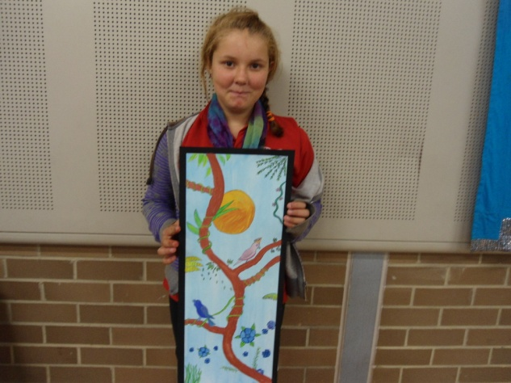
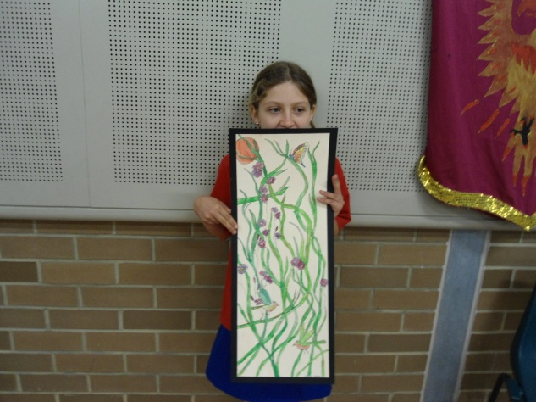

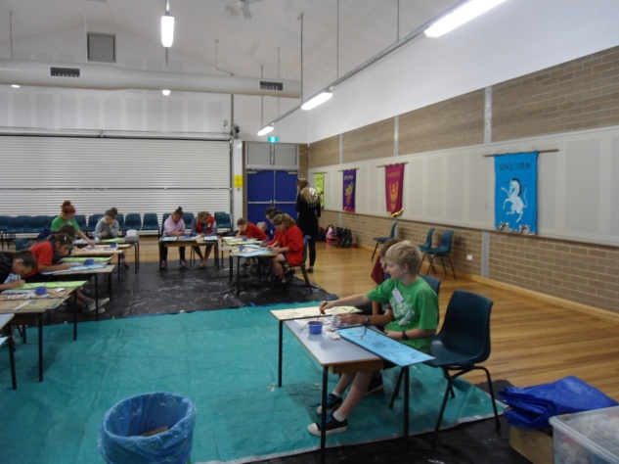

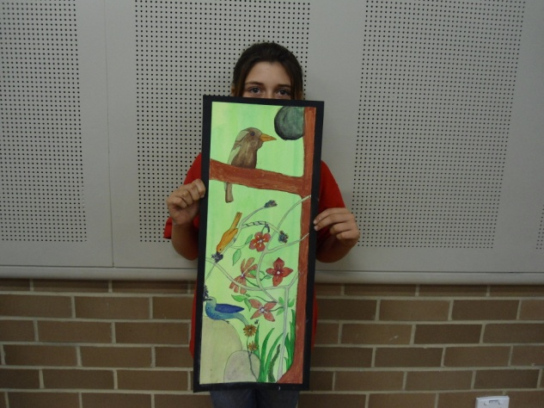
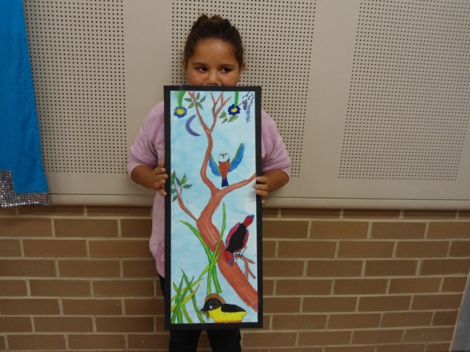
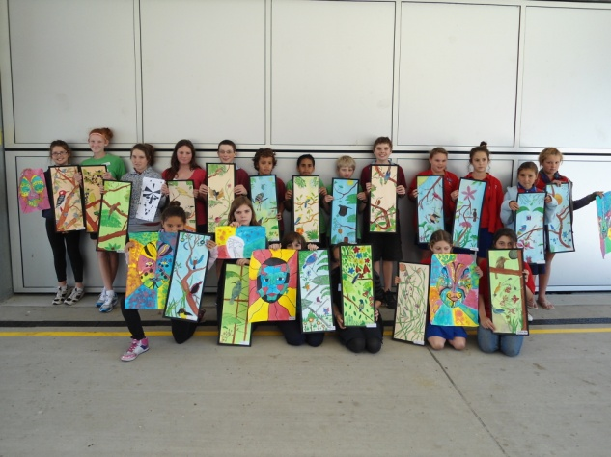

Dear Parents, Carers, Students & Community Members,
Welcome to week 9 with PLP’s well under way. It is great to see so many parents coming to PLP meetings to support their child’s learning. The students are all very aware of their levels and their targets, home support is essential for a child to reach their potential.
K/1 PLP’s took place today and Year 6 PLP’s will take place tomorrow (Tuesday). If you have been unable to attend your child’s PLP please talk to the teacher about setting another time which suits.
Year 4/5 assembly will take place on Wednesday at 2.45pm. Come along and support your children being recognised for their achievements and entertaining everyone with their item.
We hope you have your ticket for the Aboriginal Film Festival on Thursday night at 6pm. This is always a great night of fun and friendship. Come and judge the student art work, enjoy the movies, meal, trivia and clay modelling. There will be prizes and fun for all. Tickets are available at the school office for $20ea. BE QUICK – NUMBERS ARE LIMITED!

It is ‘Talk like a Pirate’ time again and we will be having ‘Pirate Day’ on Friday. Help your kids get into the spirit and dress up like pirates.
Staff will be attending a Staff Development Day on Saturday with Greg Griffiths around “Boys Engagement in Literacy”.
Spelling Bee 2011 is on next Tuesday at 2pm – help your kids with the words and come along to support them in the Spelling Bee. Knock out rounds will take place in class before the day.
Our Attendance Rewards Day will take place next week on Wednesday. Unfortunately a number of students have had many days away this term and will be remaining at school for activities. Regular attendance at school is important for your child to keys up with required learning. Please let the school know the reason if your child is away.
Our voucher tally for Coles is now 1,885 and Woolies is 310. Keep the vouchers and dockets coming in. Collection finishes on 18th October.
Students in Yrs. 3 & 5 will receive their NAPLAN (National Assessment Program in Literacy & Numeracy) results this week. The results will be posted home to parents/carers. If you have any questions about the reports or the information provided, please do not hesitate to come and see us or call us at school.
Have a great week!

Lesley Mills,
Principal.
TIPS FOR HELPING YOUR CHILD’S LEARNING:
- You are helping to improve your child’s literacy skills when you encourage your child to use new words.
- You are helping to improve your child’s numeracy skills when you ask your child to weigh and measure ingredients for cooking.
- You are helping to improve your child’s social skills when you build positive experiences with your child.

Term Three Canteen Roster
Week/Dates | Monday | Thursday
Wk 9 - 12 & 15 Sept | Di/Chris | Di/ Richelle
Wk 10- 19 & 22 | Di/Chris | Di/ Richelle

WEEK | WHAT’S HAPPENING
9 | Monday 12th September  K/1 – PLP’s  Tuesday 13th September  Year 6 – PLP’s  Wednesday14th Sept.  Yr.4/5 Assembly  Thursday 15th Sept.  Film Festival Night 6pm  Tickets available at school office.  Friday 16th September  Pirate Day  Saturday 17th September  Staff Development Day
10 | Monday 19th September  Performing Arts Concert  Casino.  Tuesday 20th September  Spelling Bee  Wednesday 21st September  Attendance Rewards Day  Friday 23rd September  LAST DAY OF TERM 3  Students return to school  MONDAY 10th OCTOBER

Canteen News
This week’s lunch special
Available Monday and Thursday at the canteen
Beef Nachos with sour cream and avocado (optional)
Small $2.50 Large $4.00
Next week's special
Ask on the day what's available!

Casino Junior Cricket sign on will be held on 10th, 17th and 24th September at the RSM Club from 10am-1pm.
All new players please bring birth certificate.
All enquiries to Lyn McKee 0427622283

P & C News
The P & C would like to express their appreciation to Melissa Armfield and Trudy Carmichael, for their contribution to, and long service of the P & C and to Sharon White, who received a Regional Directors Award for Outstanding Contribution to Public Education, for which she was nominated by the P & C.
Thank you also to the school’s Support Staff. The P & C would like to thank Julie Davis and Margaret Somerville for their contribution to the canteen and Nancy Martin for her assistance of the P & C.
Thank you to everyone who came to the meeting last Tuesday. It was great to see so many people attending. The next P & C meeting will be on Tuesday the 18th of October at 1.00 pm.
Agenda -
Financial report
Principal’s report
Canteen Report
Volunteers Grant
Active Kyogle Grant
Uniform Shop
2011 Raffle
Tabulam Race Day Fundraiser
*Tickets for the 2011 Big Raffle will be available at the office by next week. Sorry for the delay.

Nippers
Sign on Dates
18th Sept and the 25th Sept .
From 9 am Evans Head Surf Club
all previous and new members welcome
If you have turned 5 years old we want you.
For information contact the club
evansheadcasinoslsc@bigpond.com
or follow us on facebook

