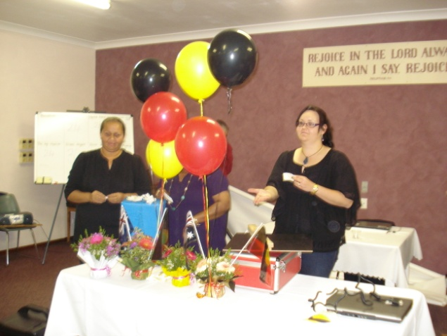

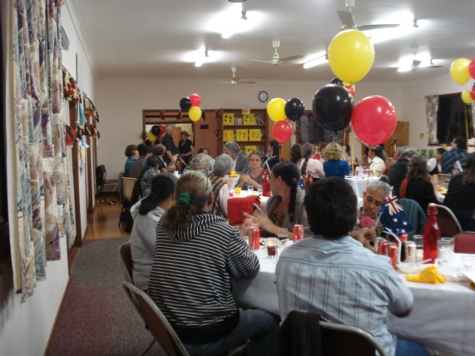

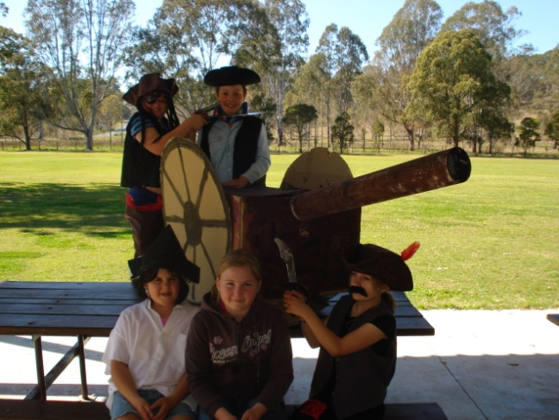

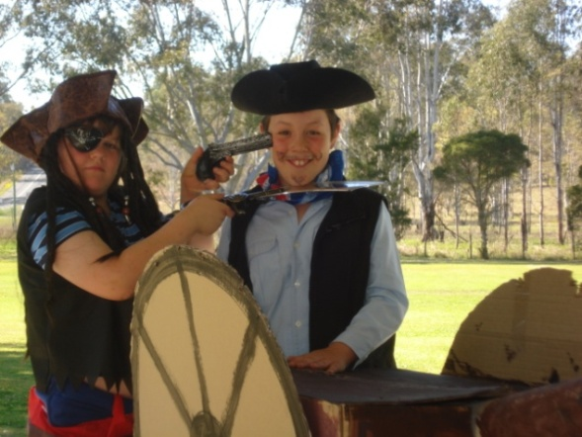

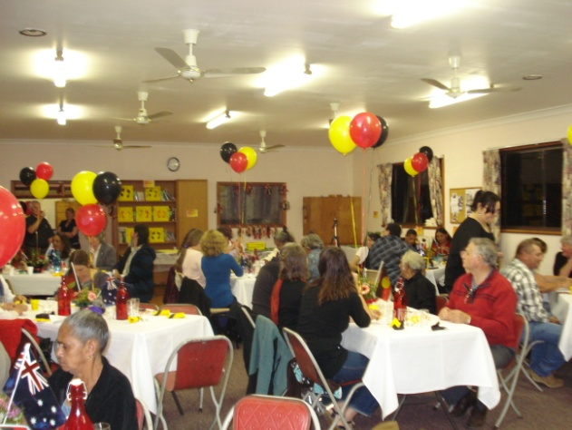

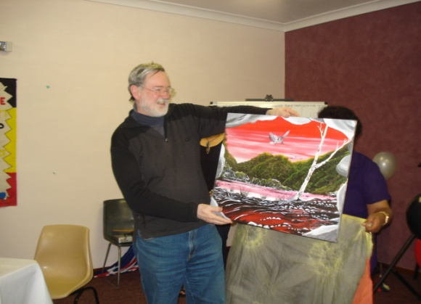

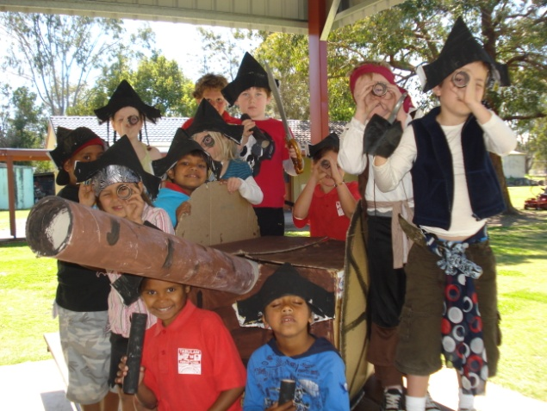

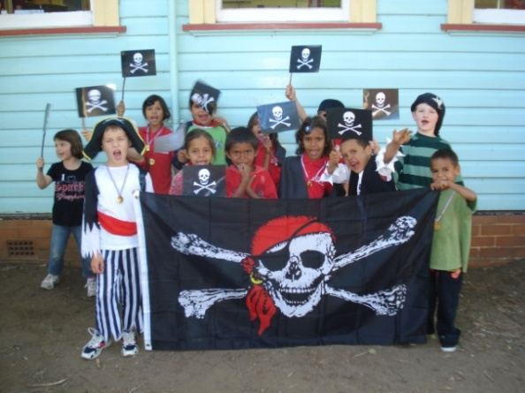

Dear parents, carers, students & Community Members,
Welcome to week 10, the last week of Term 3. It has been a very busy term and the last week is no different with many activities for all.
Our Aboriginal Film Festival was once again a great night and thoroughly enjoyed by all who came along for the fun. Thank you to Mrs. Elwell, Aunty Carmel and Aunty Selina for all their hard work organising the event. Thank you also to Sandy and Judy for their help in setting up.
Winners of the student art competition were:
Kindergarten: Amarochie Walker
Year 1: Haylee White
Year 2: Michael Connors, Shaquille Walker, Azrianna Holt
Year 3: Crystal Ross
Year 4: Cleo Findlay
Year 5: Samantha Armfield
Year 6: T.J. Walker

We made an important announcement on the night. TABULAM PUBLIC SCHOOL are the recipients of a $50,000 IMPACT AWARD from the National Banks Schools First Program. We received the award for improving student outcomes through community and school partnership. There will be a PRESENTATION & LUNCH + ACTIVITIES on Thursday 22nd Sept. at 12pm-2.30pm. Part of this presentation will be the PRESENTATION of PLP achievement certificates and recognition of student targets for term 4. Please come along and join us for the presentation and lunch and take pride in the way the community and school work together for our student’s education.
Year 4/5 did a great job for the last class assembly for the year – well done!
It was excellent to see so many students taking part in the ‘Pirate Day” on Friday. We talked like pirates, made treasure maps and some even had a treasure hunt and found treasure!
Due to the number of events we have had to juggle this week around– the Spelling Bee & Rewards Day have changed times. Rewards Day ( for students who had no more than 5 days away this term) will take place tomorrow, Tuesday at Lismore Bowl and Heritage park. Students attending need to bring their permission slip and $10 and take their little lunch, drink and big lunch and need to wear school uniform on the day.
Our Spelling Bee final will now be on Wednesday at 10am. Come along and support your children who have been working hard to learn their words.
Thursday is a big day which will be attended by a number of special guests, students, staff and community. Lunch will be provided and there will be round robin activities after lunch. Come along at 12pm. Aboriginal community members are invited to a Yarn Up with the Regional director of Education, Peter Haig between 11am- 12pm.
Our NAPLAN results arrived last week showing great strength in student growth between Yr. 3 and Yr. 5 in spelling & numeracy higher than the region and state. Our students also performed very strongly in the writing task. Areas requiring improvement are reading, grammar and punctuation and staff will be planning programs for 2012 around this information.
Next term we will be preparing our Annual School Report and a requirement of this report is that we survey parents/carers for information. There are 2 surveys attached to this newsletter; One around bullying and the other around school satisfaction. We would like you to return these as soon as possible to assist us to plan for 2012 and beyond, making our school the best it can be for your children.
Next term I will be taking the first 3 weeks on long service leave and visiting family in the U.K. Mrs. Bailey will be relieving principal for this time.
We wish everyone a safe and happy holiday and students return on Monday 10th October – including Transition students.
Our voucher tally for Coles vouchers is 2,360 and for Woolies is 372. Keep collecting vouchers over the holidays and drop them into school first week back. Collection of these vouchers and dockets ends on 18th October.

TIPS FOR HELPING YOUR CHILD’S LEARNING:
- You are helping to improve your child’s literacy skills when you encourage your child to spell new words and praise the parts that they got right.
- You are helping to improve your child’s numeracy skills when you talk about shopping to a budget. “What can we buy for $5?”
- You are helping to improve your child’s social skills when you are clear on your own beliefs and values and share them with your child.

Lesley Mills
Principal

WEEK | WHAT’S HAPPENING
10 | Monday 19th September  Performing Arts Concert  Casino.  Tuesday 20th September  Attendance Rewards Day  Wednesday 21st September  Spelling Bee – 10am  Thursday 22nd September  Yarn Up for Aboriginal Community Members, with Regional Director Peter Haig. – 11am  PLP Celebration & NAB Schools First Awards Celebration and lunch. 12pm.  Friday 23rd September  LAST DAY OF TERM 3  Students return to school  MONDAY 10th OCTOBER
WEEK 1 – TERM 4 | Monday 10th October  All Students return to school including Transition students

