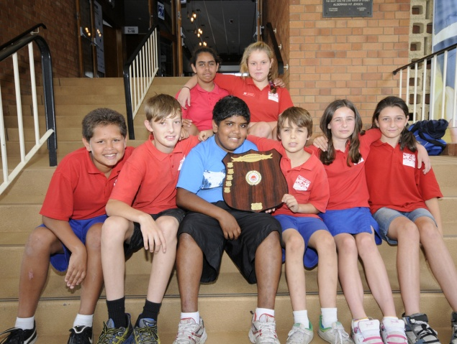

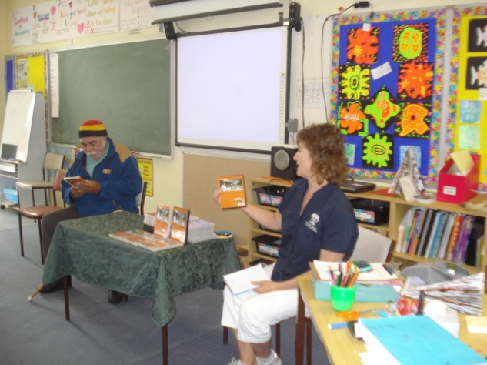

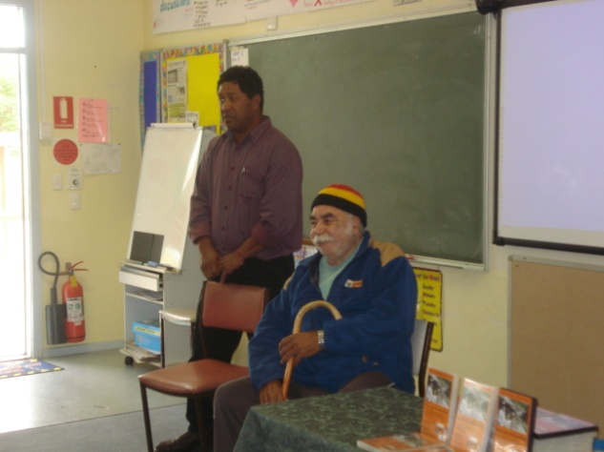

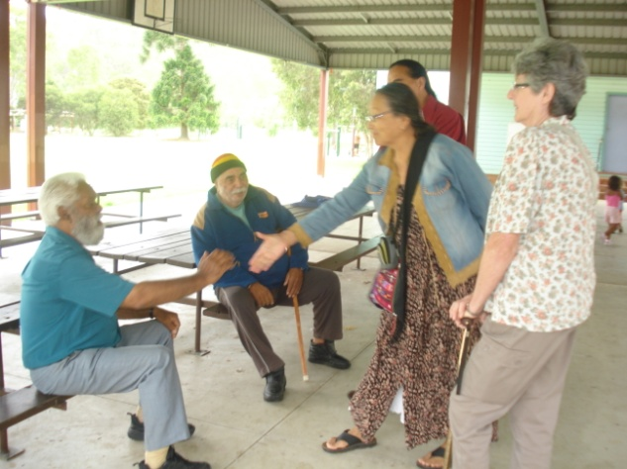

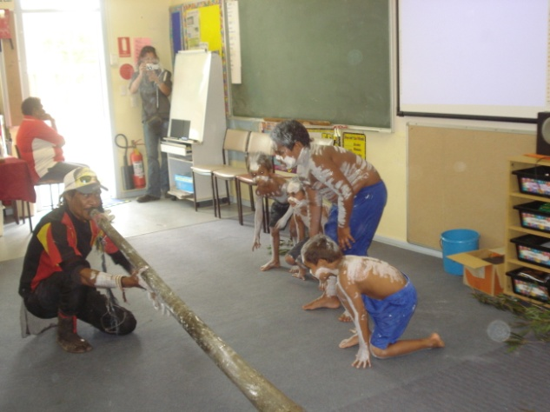

Dear parents, Carers, Students and Community Members,
Welcome to week 9, and congratulations to Yr. 6 for putting on a great assembly last week. We also celebrated students achieving their PLP targets at an assembly on Friday. Well done to all.
Tomorrow Tuesday is our Annual Presentation morning, where our students receive awards for their great work during the year. Please come along and support your children. You are welcome to join us back at the school afterwards for morning tea.
Carols night will be on Wednesday 7th December, at the school, commencing at 6.30pm. There will be a BBQ available for sale and the canteen will be selling drinks and chips. The following glow items will also be on sale on the night: Flashing bubble gun $4; Star Spinner $4.50; Flashing dreadlocks headband $3; Fibre Optic Mohawk $3.50; Flashing Santa Hat $2; Flashing Head Bopper Santa $2 and Flashing Halo Headband $3.50
The Life Education Van will be at Tabulam School on Wednesday 7th and Thursday 8th December. Cost for the van will be $5 per student. Please return attached note and money as soon as possible.

Christmas Tree/Dance will be held on Tuesday 13th December, at the school. If you wish your child to receive a present from Santa, cost will be $5 per student enrolled at Tabulam School and $3 for preschoolers. This money needs to be paid before Tuesday and no money will be accepted on the night.
Attendance Rewards Day will be held on Wednesday 14th December. Children who are eligible to attend will receive a separate note. They will be going to the Cinema in Lismore to see “Arthur Christmas”. Cost will be $10 per student.
On Monday 12th December we are having an AUSTCYCLE Bike Safety day. Students are encouraged to bring their bikes and helmet for a bike safety check and to learn some riding skills. All children who wish to participate must return a signed registration form (form attached.)
ALL LIBRARY BOOKS MUST BE RETURNED AS SOON AS POSSIBLE. $10 WILL BE CHARGED TO REPLACE ANY UNRETURNED BOOKS.
Have a great week!

Lesley Mills,
Principal

Tips for helping your child’s learning.
- You are helping to improve your child’s literacy skills when you show by your behaviour that you are listening by asking questions and adding information.
- You are helping to improve your child’s numeracy skills when you talk about the numeracy required in the work you are doing like cooking, building, dressmaking, concreting, boating, driving, shopping, etc.
- You are helping to improve your child’s social skills when you teach your child about personal safety, saying “No” when they feel uncomfortable.

Tabulam Public School P & C Update, Week 9

There will be a special meeting to organise coming events after the presentation on Tuesday.

Agenda-

- Correspondence

- Active Kyogle Grant

Acquittal

- Carols by Candlelight

roster

- Christmas Tree Night

- Athletics carnival 2012

The canteen will be open on Carols by Candlelight, Wednesday 7th December, for drinks and snacks (no meals).

At Christmas Tree and Dance Night, Tuesday 13th December, there will be a BBQ with steak and sausages, as well as drinks and snacks.

There will be a raffle with several prizes, kindly donated by: K mart, Coles, Casino RSM Club, Bunnings, Spotlight, Casino DIY Hardware, Upper Clarence District Trading Co-operative, Bev Firth Designer, Office Works, Madhouse Discount Variety, Terry White Chemists, and Scrivener and Web, Chemists, McDonald’s Pharmacy and more.

Tickets will be $1 each and available on the night.

Week | What’s Happening
9 | Tuesday 6th December  Annual Presentation + opening of COLA  Wed.7th-Thurs.8th December  Life Education Van  Wednesday 7th December  Carols Night – 6.30PM  Thursday 8th December  Year 6 visit to Ballina Water Slide
10 | Monday 12th Dec.  Austcycle Bike Safety Day  Yr. 6 Graduation Dinner.  Tuesday 13th December  Christmas Tree/Dance  Wednesday 14th December  Attendance Rewards Excursion  ....................................................  Student’s last day Friday 16th  December.  Students Yr.1-6 return Monday 30th January. Kindy returns Tuesday.31st January. 2012

Canteen Roster Term Four
Week/Dates | Monday | Thursday
Wk 9 5 & 8 Dec | Di/Chris | Richelle/Kathy
Wk 10 12 & 15 Dec | Di/Chris | Kathy/Kylie
- Monday’s back up: Sharon White
- Thursday’s back up: Rachel Findlay

Want to get back into work or study but not sure where to start?
Wollongbar TAFE’s Preparation for Work and Study Course is a great stepping stone to your goals. It is flexible so you can choose the subjects that suit you for getting back to work or preparing for a future study area. With Job Seeking and Study Skills, and 2 x 2 hour computer sessions each week, you’ll get the edge. The course includes the option of work experience.
Supportive and friendly, within school hours,
Tues, Wed & Thurs each week of term. There are no fees.
For more information for Semester 1, 2012, phone Wollongbar Campus on 6620 4700.

..........................................................
Parental permission – Life Edn.Van.
I hereby give permission for my child/children ...........................................................
To participate in the lessons in the Life Education Van.
Signed: ..............................
Parent/Carer
Amount enclosed: $

........................................................................

Christmas Tree/Dance Permission Note.
I wish my child/children Name/s:.......................................................................................................
To receive a present from Santa.
PreSchooler Name:
...................................
.....................................
Signed: .........................................
Parent/Carer

Cost: $5 for school students
$3 for preschoolers

...........................................................
...........................................................

