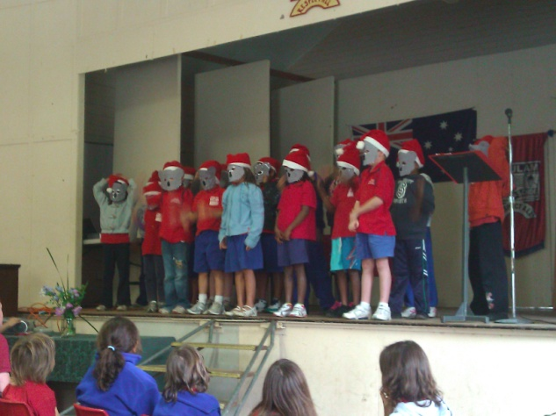

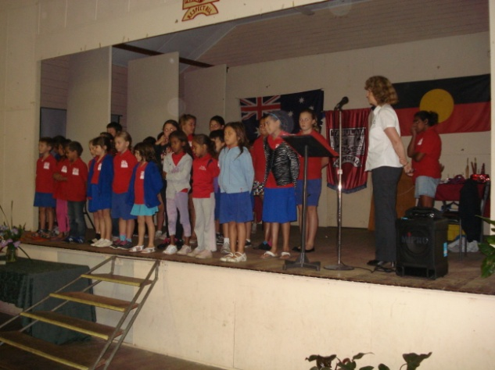

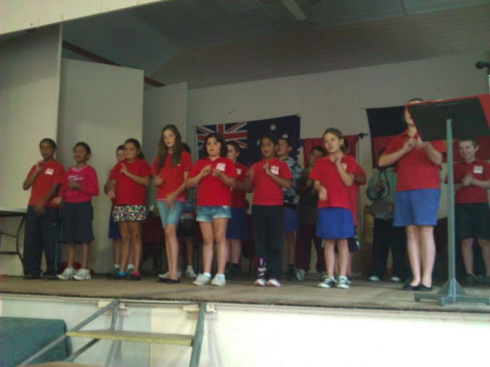

MERRY CHRISTMAS EVERYONE!
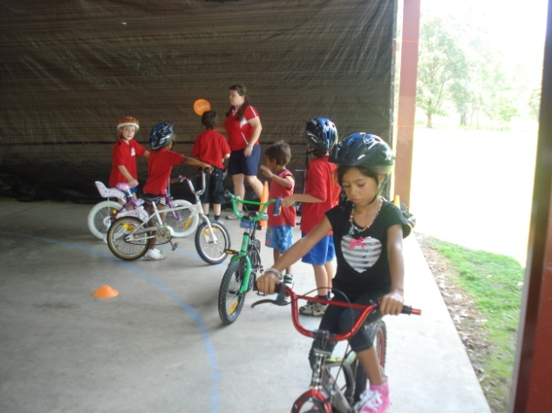
Bike Safety Day

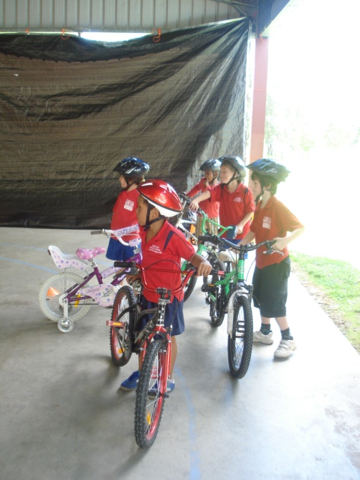

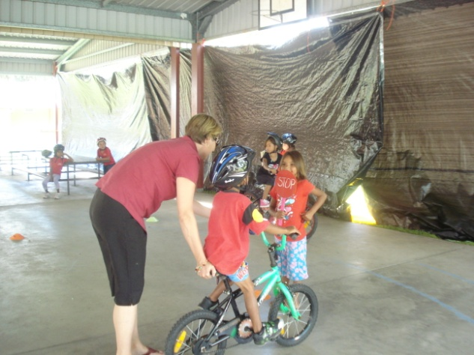

Dear Parents, Carers, Students and Community Members,
Welcome to week 10, the last week of school for 2011.
Students finish school on Friday but staff will be taking part in a Staff Development Day on Monday 19th December to make preparation for an excellent 2012 school year.
Thank you to all who attended our Presentation Assembly last Tuesday. It is great to see how far students have come in the space of 12months. Congratulations to all students.
Year 6 had a great day at the Ballina water slide as part of their prize for their Northern Star news papers in Education prize. Thanks to Mrs. Wilkinson, Ms. Owens and Aunty Selina for taking them.
Today students took part in a bike safety day where they were taught practical safety tips for keeping their bike in order and riding safely on the road.
Unfortunately due to the rain we had to cancel carols last Tuesday, but the choir will be singing their carols at our Christmas Tree which will take place at school at 6pm tomorrow, Tuesday 13th December. Come along and join us in a fun evening. BBQ & Carols 6pm, Santa 7pm then dancing

for all. Glow items will also be on sale
Eligible students will be attending an Attendance Rewards Day excursion on Wednesday. Students will travel to the cinema in Lismore to see ‘Arthur Christmas”. Students not eligible will take part in activities at school.
It has been a very busy year and we would like to take this opportunity to thank everyone for the support given to Tabulam Public School.
I would especially like to thank the great team of teachers, classroom support and office personnel who are passionate about our school and work with great dedication to give yur children the best education possible.
Thank you to everyone for your support during 2011 and we look forward to making 2012 an even more dynamic year for the education of Tabulam students. We wish everyone a Merry Christmas, a Happy New Year, and a safe and happy holiday.

Cheers.

Lesley Mills,
Principal.

Tips for helping your child’s learning:
- You are helping to improve your child’s literacy skills when you talk normally and use adult words.
- You are helping to improve your child’s numeracy skills when you ask your child to estimate the cost of two purchases, apples plus bananas.
- You are helping to improve your child’s social skills when you listen to your child’s opinions even if you do not agree with them.

Tabulam Public School P & C Update, Week 10At Christmas Tree and Dance Night, this Tuesday 13th December,there will be a BBQ with steak and sausages (vegie patties are also available on order), as well as drinks and snacks. There will be a raffle with several prizes, kindly donated by K mart, Coles, Casino RSM Club, Bunnings, Spotlight, Casino DIY Hardware, Upper Clarence DistrictTrading Co-operative, Bev Firth Designer, Office Works, Madhouse Discount Variety, Terry White Chemists, and Scrivener and Webb, Chemists, McDonald’s Pharmacy, The Book Warehouse ,Bev Firth, Designer and more.Proceeds of the raffle will be donated to the school and used P & C funded activities. Tickets will be $1 each and available on the night. Santa will arrive at 7.00pm.Thank you to Tabulam Rural Fire Service.

Tabulam Primary School Parents and Citizens Association Special general meeting 6th November, 2011 Meeting opened:11.30am In attendance: Shantala Zervos, Sharon White, Trudy Carmichael, Kathy Tasker, Kylie Martin, Melissa Armfield and Rachel Findlay. Apologies: Chris Zervos and Lesley Mills. Correspondence In: -P & C mail out -Janelle Saffin: Dr Tierney’s retirement -Spotlight: Donation of $20 voucher. Correspondence Out: -Coles and K Mart: Thank you letter for voucher donated. -Certificates of Appreciation: Coles, Bunnings, K Mart, Office Works, Casino DIY Hardware, Terry White, Chemists, Spotlight , Pete’s Plants, Video Easy, Madhouse Discount Variety ,The Hungry Gecko, Tabulam News , and Upper Clarence District Trading Co-operative. Business arising from the minutes: 1.Active Kyogle Grant Acquittal – - Kylie to organise acquittal paperwork. -Letters of support from P & C, Lesley, Aunty Carmel and Paster Paul to be organized in 2012. Mvd: Rachel 2nd: Kylie Carried -Chest freezer-organise loan from Streets in the New Year. Mvd: Kylie 2nd: Kathy Carried 2. Carol by Candlelight. -Snacks and Drinks will be available in the canteen and plenty of helpers will be there.

3. Christmas Tree Night- -Menu- Steak & sausage, sandwiches with vegie patties available, coleslaw, snacks and drinks, including cans. Mvd: Kylie 2nd: Kathy Carried - Thank you to Kylie for ordering, shopping for the night. -Santa will arrive at 7.00pm.Thank you to Melissa, Trudy, Kylie and Marnie .Kylie to give drinks & lollies to Marnie. –Thank you for the donations to the Christmas raffle from-K Mart, Spotlight, Bunnings, Office Works, Casino DIY Hardware, Madhouse Discount Variety, Coles, Smith’s Butchery, Upper Clarence District Trading Co-operative, McDonald’s Pharmacy, Scrivener and Webb and Terry White, Chemists, The Hungry Gecko and Tabulam News. Rachel to pick up remaining donations and Chris to pick up Smith’s Butchery voucher. Canteen to provide 6 bottles of water, drink/snack samples and 2 canteen vouchers to the value of $3.50. $15 can be spent on materials for presentation of prizes if necessary. Letters and certificates of appreciation to be sent. Mvd: Rachel 2nd: Sharon Carried -Preparation on the day will be going on between 9.30am- 6.00pm for those who can make it during this time - COLA to be decorated ,raffle prizes and raffle to be organized and the canteen/BBQ area prepared for a 6.00pm start. Mvd: Melissa 2nd: Rachel Carried General business: 1.Swimming carnival 2012 , Feb 3rd -The swimming carnival will be a ‘red day’ when treat foods will be available.

Mvd: Rachel 2nd: Kylie Carried -Menu-Pies large and party, sausage rolls, bacon and cheese rolls. Cans, poppers, water, chips, jumbo snakes, mixed lollies, fruit stick ice blocks if possible. Kylie and Chris to organise. Mvd: Kylie 2nd: Melissa Carried -Menu to be advertised in Newsletter in week 2. P & C to bring extra rubbish bins on the day. Mvd: Melissa 2nd: Sharon Carried -Roster-Chris, where available, Melissa, Sharon, Kylie, Rachel. Next meeting: Tuesday 7th February at 1.00pm. Meeting closed: 1.30 pm

Prepare to re-train at TAFE : If you want to change jobs, but you’re worried about retraining and finding new work, this course will suit you. The certificate 111 in Employment and training (Wollongbar TAFE Semester 1, 2012) will help you build your skills and confidence so you can successfully undertake further study and apply for a job. The course has a Community Services focus, but is suitable for study and work in any area. You’ll find direction and gain study skills, interpersonal communication skills, job seeking skills and essential computer skills. You’ll also take part in work experience in an area of your choice. Email Pam at pam.timms@det.nsw.edu.au or contact the Campus on 66204700

