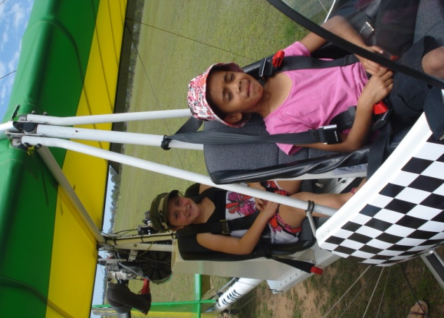

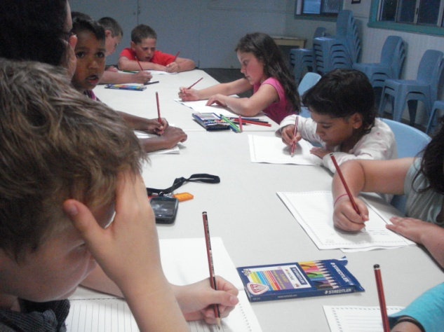
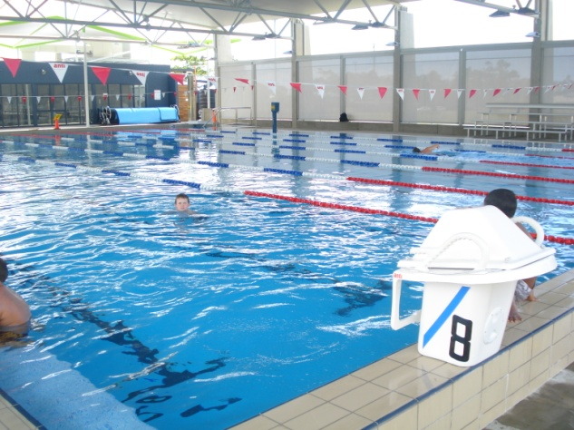

Dear Parents, Carers, Students and Community Members,
Welcome to week 6 as the year quickly moves into end of year activities.
Year 2/3 returned from camp as very happy and tired campers full of stories about aerodromes, flying fox experiences and the great time they had. Thanks to Mrs. Lane, Mrs. Elwell and Marg Somerville for giving up their time to give the students this great experience.
Our school presentation to principals from around Australia at the National Dare to Lead conference in Sydney was received very well. It is to the credit of our whole school community that our school is recognised for the wonderful school it is.
Today students all took part in a Christmas craft day to create some wonderful Christmas presents and to give students a stimulus for writing tasks over the next few days. Their writing will be put together with photos from the day to create books for the students to read in class. Thank you to Mrs. Bailey for her organisation.
There will be a SIP meeting at the Land Council office at 10am-1pm on tomorrow Tuesday (See attached

flyer). Come along and have some say about your child’s education.
Year 4/5 PLP’s will take place on Tuesday this week and Wednesday next week. Please try to make time to come in and talk with your child and their teacher about their learning and aspirations for their future. Appointment notes went home last week, please contact the school if you need to change your time.
Assembly will be presented by Year 2/3 tomorrow Tuesday at 2.45pm, come along and support 2/3 for their last assembly for 2010.
On Wednesday teachers will all be working with Sue Smith (consultant) on some professional learning around “Prioritising Grammar”. This is an area of need for our students and our teachers are always interested in improving their own knowledge to give our students the best education we can.
K/1 will head off on their excursion for 2010 on Thursday. K/1 are going to Evans Head for the day and coming back to school for dinner, and a movie. This year K/1 are not going to stay overnight as a number of the students are quite young.
Swimming school will start next week, and all students will need to return their permission note

(permission note is attached to this newsletter) and $5 before Friday this week. If you would be able to help at swimming school, it would be greatly appreciated.

Lesley Mills,
Principal.

THIS WEEK’S LUNCH SPECIAL IN CANTEEN
Available MONDAY and THURSDAY
SWEET & SOUR PORK with RICE
Small $2 Large $3
NEXT WEEK’S SPECIAL
CHICKEN CAESAR SALAD
Small $2.50 Large $4.00
.........................................................

WOODENBONG

Yowie Country

MARKET
LAST SATURDAY EVERY MONTH
8am-3pm Woodenbong Hall & Grounds
Free Live Music. Jammers welcome. Variety of indoor/outdoor stalls. Hot food. Children’s Playground. Wheelchair access & Amenities. W.A.G. (Woodenbong Arts Group Inc.) displays & interaction. Insured stall site $12

NEXT MARKET SATURDAY 27th November
Please Note: the Christmas Market brought forward 1 week to 18th December 2010
Contact: Carey 0266351176
K/l have been doing outstanding handwriting. Aunty Carmel and I are very proud of their efforts and great improvement. Samples of their work are attached.
TERM 4 | What’s Happening
6 | Monday 15^{th November}  – Christmas Craft Day  Tuesday 16th November  2/3 Assembly 2.45pm  Yr.4/5 PLP  Thursday 18th November  K/1 Excursion
7 | Monday – Friday 22nd-26th  Swimming School – K-2  Monday 22nd November  Yr.6 PLP  Tuesday 23rd November  Yr. 6 PLP  Wednesday 24th November  Yr.4/5 PLP
8 | Monday-Friday 29th – 3rd Dec  Swimming School – 3-6  K/1 - PLP  Tuesday 30th November  Year 6 Assembly -2.45pm  K/1 - PLP  Wednesday 1st December  Carols Night
9 | Tuesday 7th December  Annual Presentation – 10am  Friday 10th December  Byron Bay – Circus School
10 | Monday 13th December  Attendance Rewards Day – Bonalbo Pool  Tuesday 14th December  Christmas Tree  Wednesday 15th December  Students last day at school
Canteen Roster Term 4 – 2010
Mon | Name | Thur | Name
15/11 | Sue/Sharon | 18/11 | Kylie
22/11 | Sue/Di | 25/11 | Di
29/11 | Sue/Di | 2/12 | Rachel
6/12 | Sue/Di | 9/12 | Di
13/12 | Sue

