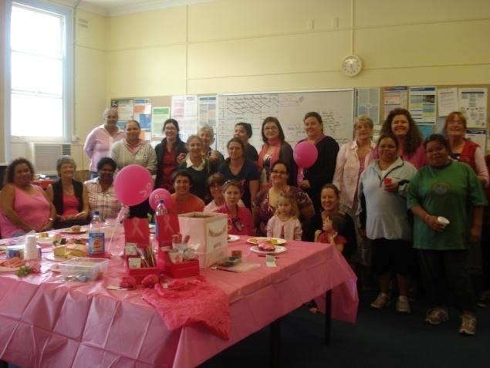

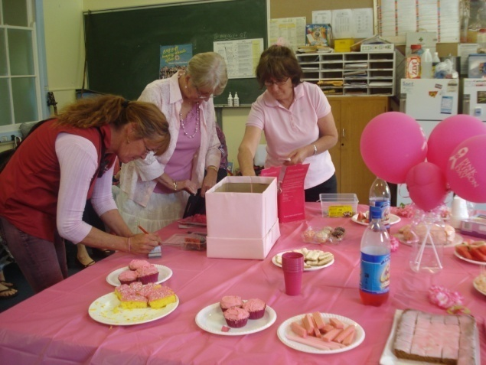
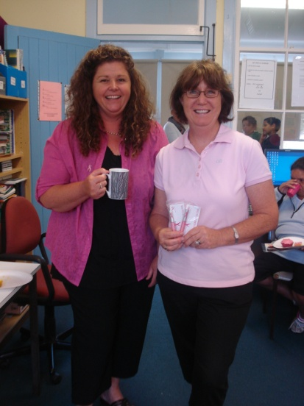
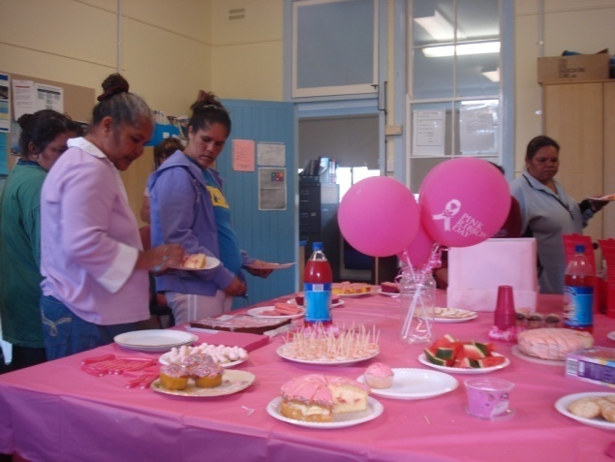

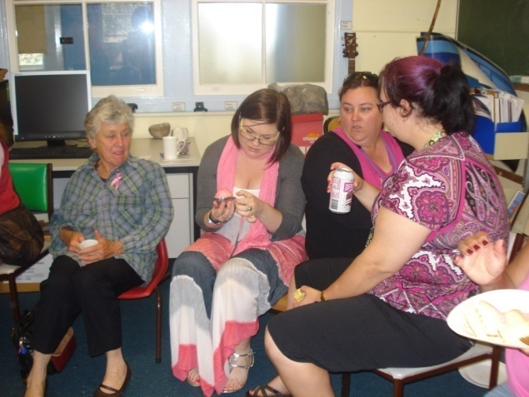
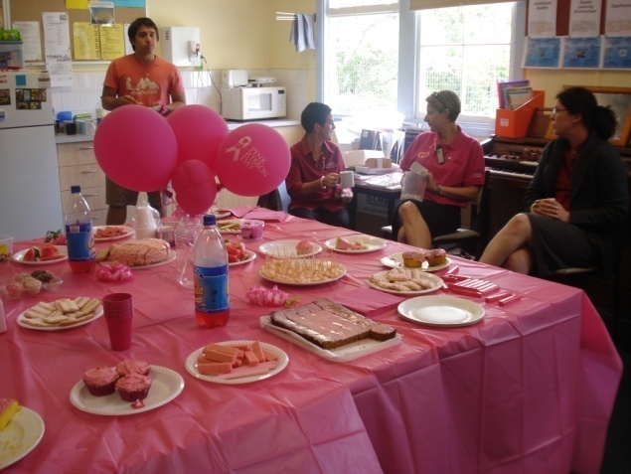
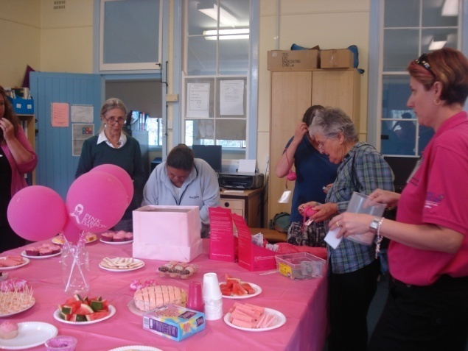

Dear Parents, Carers, Students & community members,
Welcome to week 3 and hopefully the end of the rain!
Today we held our Pink Ribbon morning tea to raise money for Breast Cancer Research. It was an excellent event with everyone dressed in pink, pink nails, pink hair, pink food and pink raffle and lucky door prizes. Our school raised $592.60.
The raffle winners were:
1st: Kerrie Anderson
2nd: Tammy Wilkinson
3rd: Nancy Martin
Lucky Door Prizes went to: Margaret Somerville, Judy Torrens, Krystle Torrens, Shoanna O’Connor, Christy Cubby.
Congratulations and thank you to all who supported our morning tea for this worthwhile charity. Special thanks to Mrs. Marnie Bailey, who organised the event for us.
Tomorrow (Tuesday) we have a parent numeracy and literacy workshop with Anne Bowden the PSP community liaison officer. Anne will play some games and provide parents with simple ideas to help students learn at home. Everyone is welcome – morning tea and lunch will be provided. Come along, meet other parents and have some fun.
Year 4/5 will present the first assembly for the term at 2.45pm on Tuesday. They would love your support. Many students are in line for Golden Book awards this week for ‘excellent work in class’. Keep up the good work everyone.
On Thursday, year 6 will be attending a presentation by Yr.7 Bonalbo students and a kite workshop as part of their transition to high school program. Students received a permission note last week.
On Friday I will be presenting a National Partnerships meeting in Lismore related to the funding we will receive next year. We have many surveys back which will help decide the directions we will take. This is the last week to return surveys and enter into the prize draw for a DVD player. The survey was posted home but there is one attached to this newsletter for your convenience. All students receive a chocolate frog when their family’s survey is returned.
Congratulations to Chloe White and Abby Martin for their participation in the MS Readathon. Chloe and Abby raised an impressive $915.30 for Australians living with multiple sclerosis. A fantastic effort for 2 students!
On Friday 29th October, it is bandana day. This day is for supporting kids with cancer. We will be selling bandanas for $4 and pens for $2, all available at the front office from Mrs. Martin. Friday will be a mufti day on Friday for a gold coin donation.
We will be having a Halloween fun day next Monday. The canteen will have Halloween food, classes will have Halloween activities and everyone will be getting dressed up, it should be a good day.
As the year progresses it is important to remember that regular attendance is essential for student learning. Whilst most students have excellent attendance a few are having too many days away from school. All absences must be explained by note or a phone call. It is also important that students arrive at school on time as consistent lateness results in missing out on a great deal of literacy learning (we have reading, spelling and writing at the beginning of every day). We have been recognised for having excellent improvement in our attendance rates, let’s work together to keep it that way. Our attendance reward day for Term 4 will be a party & fun day at the pool in Bonalbo.
Using our Dare to Lead award money we will be taking all students to the Byron Bay Circus School on Friday 10th December. This will be a great experience for all of our students.
Congratulations to Trent McGrady for winning the Junior Wooli River Fishing competition last Friday. He attended the competition as part of the Upper Clarence Fishing & Restocking group.
Have a great week!

Lesley Mills,Principal
Canteen Roster Term 4 – 2010
Mon | Name | Thur | Name
18/10 | Sue/Di | 21/10 | Di
25/10 | Sue/Di | 28/10 | Di
1/11 | Sue/Di | 4/11 | Marni
8/11 | Sue/Di | 11/11 | Di
15/11 | Sue/Sharon | 18/11 | Kylie
22/11 | Sue/Di | 25/11 | Di
29/11 | Sue/Di | 2/12 | Rachel
6/12 | Sue/Di | 9/12 | Di
13/12 | Sue

TERM 4 | What’s Happening
3 | Monday 25th October  Pink Ribbon Day – 11am  Tuesday – 4/5 Assembly, 2.45pm  Thursday – Yr 6 Transition - Bonalbo
4 | Monday 1st November  Halloween Day
5 | Tues – K/1 Assembly – 2.45pm Thursday & Friday - Year 2/3 Camp – 11th & 12th Nov
6 | Monday 15th – Christmas Craft Day  Tuesday – 2/3 Assembly – 2.45pm  K/1 Excursion – 18 Nov
7
8 | Tuesday 30th – Year 6 Assembly -2.45pm  Wednesday 1st December  Carols Night
9 | Tuesday 7th December  Annual Presentation – 10am
10 | Tuesday 14th December  Christmas Tree  Wednesday 15th December  Students last day

Tough Teeth
Protect your child’s teeth by encouraging them to eat well
Enjoy a wide variety of nutritious foods
- Enjoy healthy snacks
- Avoid snacking on sugary and sticky foods and sweets between meals
- Milk-based foods help protect your teeth
- Chew sugar-free gum to help protect your teeth.
- Looking for a dental health clinic? The NSW Centre for Oral Health Strategy recommends calling (02) 8821 4300 during business hours and quoting your suburb. From there, parents will be given the contact details for their local oral health service.
Sun Safety – five ways to be SunSmart this summer - The Cancer Council recommends these five ways to protect against sun damage when the SunSmart UV alert is 3 or above:
- Seek shade
- Wear protective clothing that covers your arms and legs and body
- Wear a broad-brimmed hat that shades your face and neck
- Wear wrap-around sunglasses
- Apply SPF30+ broad spectrum water-resistant sunscreen every two hours.
Find our more at www.cancercouncil.com.au
Practical tips for kids dealing with an online bully
Tell the bully in simple terms to leave you alone. Tell them not to contact you again. Log off immediately and stay offline for at least 24 hours.
- Do not reply to any future mail from the bully. Do not reply to taunts, emails or gossip written about you. By ignoring taunts, you take the power away from the harasser and refuse to play their game. You are now in charge.
- Never give your password or logon details to anyone, even your best friends. It’s really easy for someone to log on to your Facebook, Bebo or MySpace site and post any kind of rubbish if they know your password.
- Stay out of chat rooms where you don’t feel comfortable
- Keep all harassing emails (and any replies you’ve made) as evidence.
- If you feel you are in physical danger or if the bully has made physical threats against you,

- tell your parents immediately and they can decide if it’s appropriate to contact authorities.
For more great tips on staying safe online, see www.schools.nsw.edu.au/click

